**Software Requirements Specifications (SRS)**

**ERP SolutionforLakhsma Sweater Ltd.**

REFERENCE: GW/ERP/SRS/Inventory

**Version: 2.1**

**Date of Release: November05, 2015**



**Genweb2 Limited**

TK Bhaban (11th Floor),

13 KaziNazrul Islam Avenue,

Kawran Bazar, Dhaka 1215, Bangladesh

web: [http://www.genweb2.com](http://www.genweb2.com/)

**Contents**

Document Release History 5

1.0 Introduction 6

1.1 Purpose of SRS 6

2.0 Procurement 7

2.1 Overview 7

2.2 Functional features of inventory modules are given below 7

2.3 Inventory Process flow 7

2.4 User Class 8

3.0 Process Flow: 10

3.1 Raise Indent Process 10

3.2 Receive Goods Process 11

3.3 Receive Return Process 12

3.4 QC Process 13

3.5 Inventory Item Transfer Process 14

3.6 Item Allocation, DE allocation and Reallocation Process 16

3.7 Issue Item Process 18

3.8 Issue Return Process 19

3.9 Physical Inventory Process 20

3.10 Item Adjustment Process 21

3.11 Gate Pass Out Process 23

3.12 Gate Pass In Process 24

4.0 USE CASE Diagram 25

4.1 Raise Indent Process 25

4.2 Receive Goods: 25

4.3 Receive Return Process: 26

4.4 QC Process 26

4.5 Inventory Item Transfer Process 27

4.6 Item Allocation, De-allocation and Reallocation Process 28

4.7 Item Issue process 28

4.8 Issue Return Process 29

4.9 Physical Inventory Process 29

4.10 Item Adjustment Process 29

4.11 Gate Pass Process 30

5.0 USE CASE Details 31

5.1 UC/INV/001/ Raise Indent 31

5.2 UC/INV/002/ Edit/Modify Indent 32

5.3 UC/INV/003/ Approve Indent 33

5.4 UC/INV/004/ Cancel Indent 34

5.5 UC/INV/005/ Close Indent 35

5.6 UC/INV/006/ Receive Goods against Purchase Order 38

5.7 UC/INV/007/ Receive Return to Supplier before QC 38

5.8 UC/INV/008/ Purchase Order Cancellation for Received Return Items 39

5.9 UC/INV/009/Perform QC of receive goods 40

5.10 UC/INV/010/Receive Return to Supplier after QC 41

5.11 UC/INV/011/ Update stock with QC passed quantity 42

5.12 UC/INV/012/ Return QC Failed Quantity to Supplier 43

5.13 UC/INV/013/ Order Cancellation for QC failed items/Qty 44

5.14 UC/INV/014/ Receive replaced goods of QC failed returned qty 44

5.15 UC/INV/015/ Request for Item Transfer 45

5.16 UC/INV/016/ Approve Transfer Request 46

5.17 UC/INV/017/ Cancel Transfer Request 47

5.18 UC/INV/018/ Transfer out goods from one location by transfer note 48

5.19 UC/INV/019/ Request for item allocation 49

5.20 UC/INV/020/Approve Allocation Request 51

5.21 UC/INV/021/Cancel Allocation Request 51

5.22 UC/INV/022/Allocate Goods from Bulk Stock to EPO 52

5.23 UC/INV/023/ De Allocate Goods from EPO to Bulk 53

5.24 UC/INV/024/ re Allocate Goods from EPO to EPO 54

5.25 UC/INV/025/Issue Stock against Indent (from Production floor) 54

5.26 UC/INV/026/Issue Stock against Indent (From Employee) 55

5.27 UC/INV/027/Receive Issued Item 56

5.28 UC/INV/028/Return Issued Item 57

5.29 UC/INV/029/Physical Inventory 58

5.30 UC/INV/030/Adjust Item 58

5.31 UC/INV/031/Adjust Item(s) for item missing 59

5.32 UC/INV/032/Adjust Item(s) for Item damage 60

5.33 UC/INV/033/Out Gate Pass 61

5.34 UC/INV/034/In Gate Pass 62

6.0 Inventory Mock-up 63

6.1 Product Creation 63

6.2 Indent 64

6.3 Inventory Receive 65

6.4 Receive Return 66

6.5 Inventory QC 67

6.6 Inventory Transfer 68

6.7 Inventory Item allocation &De-allocation 69

6.8 Inventory Issue 70

6.9 Physical Inventory 71

6.10 Item Adjustment 72

6.11 Gate Pass out Process 73

6.12 Gate Pass In Process 74

Document Release History

| Sl. No. | Version Number | Release Date | Prepared By | Reviewed By | Approved By | Reasons for New Release |
| --- | --- | --- | --- | --- | --- | --- |
| 1 | 1.0 | 14th Oct, 2015 | NazifaChowdhury |  | N/A | 1st Release |
|  |  |  |  |  |  |  |

# Introduction

## Purpose of SRS

The purposes of this SRS are to clearly identify the customer requirements and provide a detailed document. The customer will review the document and approve/make change as required. It will also help the review team to be able to validate whether the customer requirements has been fulfilled.

The SRS will also help the Analyst and Designer to understand and track the Requirements for the proposed system. It will also identify a set of requirements for the Development of the project. The SRS helps to describe the behavior of the system to be developed.

# Procurement

## Overview

Inventory management is a science primarily about specifying the shape and percentage of stocked goods. It is required at different locations within a facility or within many locations of a supply network to precede the regular and planned course of production and stock of materials.

## Functional features of inventory modules are given below

* Floor Manager or Employee/ Department raises indent
* Approval Authority verifies the Indent with necessary information
* Store Keeper sends all products according to Indent information to Floor Manager or Employer or Department
* Store Keeper receives goods according to Purchase Order
* QC Authority checks quality and quantity of goods according to Purchase Order
* If goods are in good quality and exact quantity then QC accept goods and update the stock of the goods
* If goods are not in good condition and not exact quantity, QC Authority returns the rejected goods
* Store Keeper sends back all rejected goods to Supplier
* Store Keeper checks all goods and if finds any mismatch then sends the goods to Supplier
* Transfer Request Authority (Merchandiser / Storekeeper / others) sends request to Approval Authority for item transfer
* Storekeeper receives request from approval authority for transfer out item from stock
* Based on approval storekeeper can transfer item from one stock to another stock
* Items can be allocated or de-allocated or re-allocated between EPO to Bulk and vice versa
* Storekeeper can issue item to Floor Manager or Employee / Department against indent
* Floor Manager or Employee / Department can return issued item
* Storekeeper can adjust the difference item stock in between system and physical
* Item can be adjusted in case of missing or damaged

## Inventory Process flow

* Raise indent process
* Receive goods process
* Receive return process
* QC process
* Inventory item transfer process
* Item allocation, de-allocation and reallocation process
* Issue item process
* Issue return process
* Physical inventory process
* Item adjustment process
* Gate Pass Process

## User Class

|  |  |  |
| --- | --- | --- |
| User Class/ Actor | Characteristics | Responsibilities |
| Floor Manager | * Raise Indent * Receive Issued Item * Return Issued Item | * Add, modify documents * Maintain other documents related information |
| Employee | * Raise Indent * Receive Issued Item * Return Issued Item | * Add, modify documents * Maintain other documents related information |
| Indent Approval Authority | * Approve Indent | * Add, modify documents * Approve document * Add necessary comments during approval if required |
| Authority | * Cancel Indent * Close Indent | * Add, modify documents * Approve document * Provide necessary comments during approval if required |
| Storekeeper | * Receive goods against Purchase Order * Receive Return to Supplier before QC * Receive Return to Supplier after QC * Return QC failed quantity to Supplier * Receive replaced goods of QC failed returned qty * Transfer out goods from one location by transfer note * Transfer In goods against Transfer Note * In transit Item adjustment * Allocate goods from Bulk stock to EPO * De allocate goods from EPO to Bulk * Re allocate goods from EPO to EPO * Issue Stock against Indent (from Production floor) * Issue Stock against Indent (From Employee) * Physical Inventory Adjust | * Add, modify documents * Maintain other documents related information |
| Procurement/Authority | * Purchase Order Cancellation for Returned Items * Order Cancellation for QC failed items/Quantity | * Order Cancellation for QC failed items/Qty |
| QC | * Perform QC of received goods | * QC assure the item quality validation |
| System | * Update stock with QC passed quantity | * Add/modify item * System update |
| Merchandiser, Employee, Storekeeper | * Request for item transfer * Cancel Transfer Request * Request for item allocation * Cancel Allocation Request | * Add/modify item * Provide necessary comments during approval if required |
| Receive Authority | * Receive Issued Item * Return Issued Item | * Add, modify documents * Approve document * Provide necessary comments during approval if required |
| Gate Security | * Gate Pass Out * Gate Pass In | * Add, modify documents * Maintain other documents related information |

# Process Flow:

## Raise Indent Process

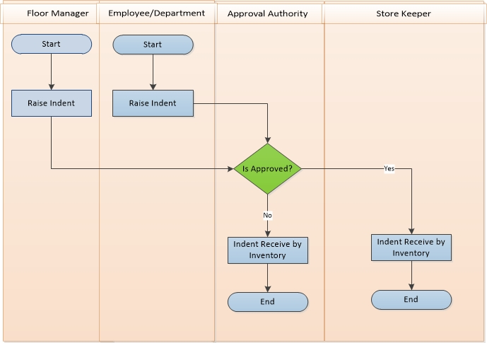

**Raise Indent Process Description:**

* Floor Manager or Employee/ Department raise Indent when they need products for production or Consumption.
* They send the Indent to Approval Authority to approve the Indent.
* Approval Authority verifies the Indent with necessary information. Depending on approval decision further process –
  + Approved: If approved, then Approval Authority sends the approval message to store keeper to take necessary steps.
  + Not Approved: If not approved, then Approval Authority cancels the Indent and stops the Raise Indent Process in the point.
* According to approval message, Store Keeper accepts Indent information with confirmation message.
* Store Keeper issue stock according to Indent information to Floor Manager or Employer or Department.

## Receive Goods Process

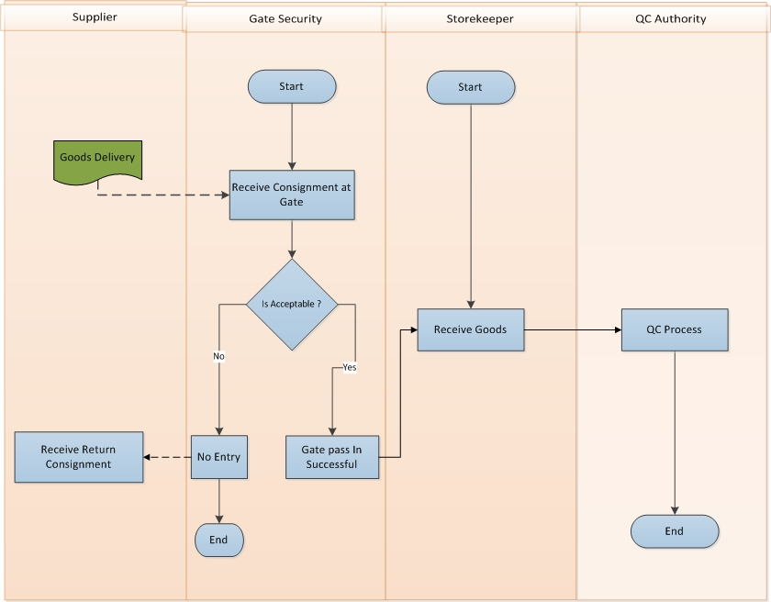

**Receive Goods Process Description**

* Supplier sends goods against Purchase Order or Commercial Invoice to requested location.
* Gate Security Check the Consignment.
* If Consignment is not acceptable then it goes back to supplier
* If consignment is acceptable then gate security allow it to move Storekeeper
* Store Keeper receives goods.
* Store Keeper confirms his acceptance as per Order and sends all goods to QC Authority for proper quality control.
* QC Authority receives all goods and ends the process.

## Receive Return Process

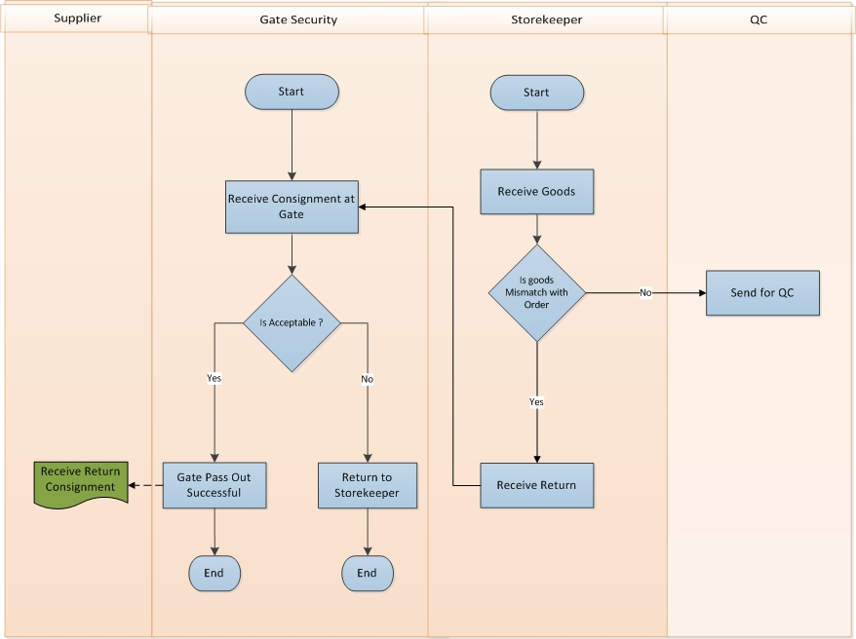

**Receive Return Process Description**

* Store Keeper checks all received goods
* If there is any mismatch against the order then storekeeper send the goods back to Supplier for further action
* Gate Security receives the request to Receive Return goods to Supplier
* If Gate Security accept the gate pass out request then the consignment goes back to Supplier
* If Gate Security don’t accept the gate pass out request then the consignment goes back to storekeeper again.

## QC Process

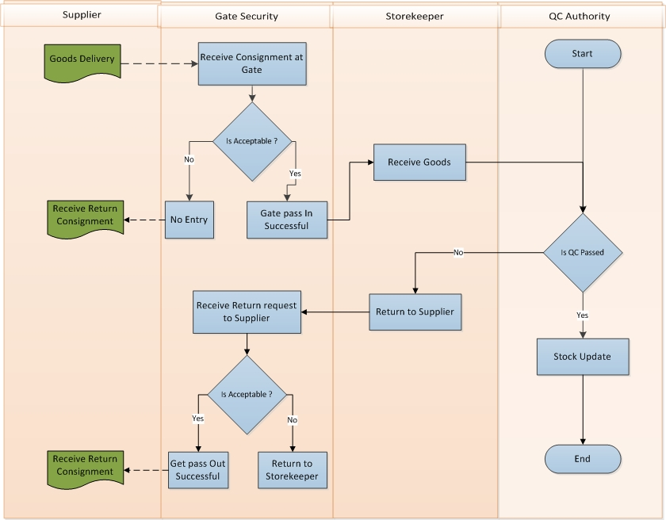

**QC Process Description**

* Supplier sends goods against Purchase Order or Commercial Invoice to requested location.
* Gate Security Check the Consignment.
* If Consignment is not acceptable then it goes back to supplier
* If consignment is acceptable then gate security allow it to move Storekeeper
* Store Keeper receives goods.
* Store Keeper confirms his acceptance as per Order and sends all goods to QC Authority for proper quality control.
* QC Authority checks quality and quantity of goods as per Order. According to QC result they take necessary decision-
  + QC Passed:
    - If goods are in good quality and exact quantity and Quality then QC accept goods and update the stock of the goods.
  + QC Failed:
    - If goods are not acceptable and not exact quantity, QC Authority returns the rejected goods to Store Keeper for Receive Return to Supplier.
* Store Keeper receives all rejected goods send by QC Authority and sends the goods back to Supplier for further action
* Gate Security receives the request to Receive Return goods to Supplier
* If Gate Security accept the gate pass out request then the consignment goes back to Supplier
* If Gate Security don’t accept the gate pass out request then the consignment goes back to storekeeper again.

## Inventory Item Transfer Process

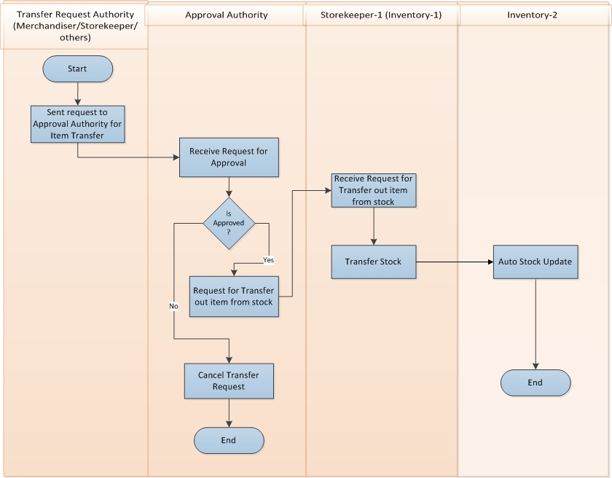

**Inventory Item Transfer Process Description**

* Transfer Request Authority (Merchandiser / Storekeeper / others) sends request to Approval Authority for item transfer.
* Approval Authority receives request for approval from Transfer Request Authority.
* If Approval Authority is not approved then cancel the transfer request.
* If Approval Authority is approved then request to storekeeper-1 (inventory-1) for transfer out item from stock.
* Storekeeper-1 (inventory-1) receive request from approval authority for transfer out item from stock.
* Storekeeper-1 (inventory-1) transfer the Item Stock.
* Stock goes auto updated from Inventory-1 to Inventory-2

## Item Allocation, DE allocation and Reallocation Process

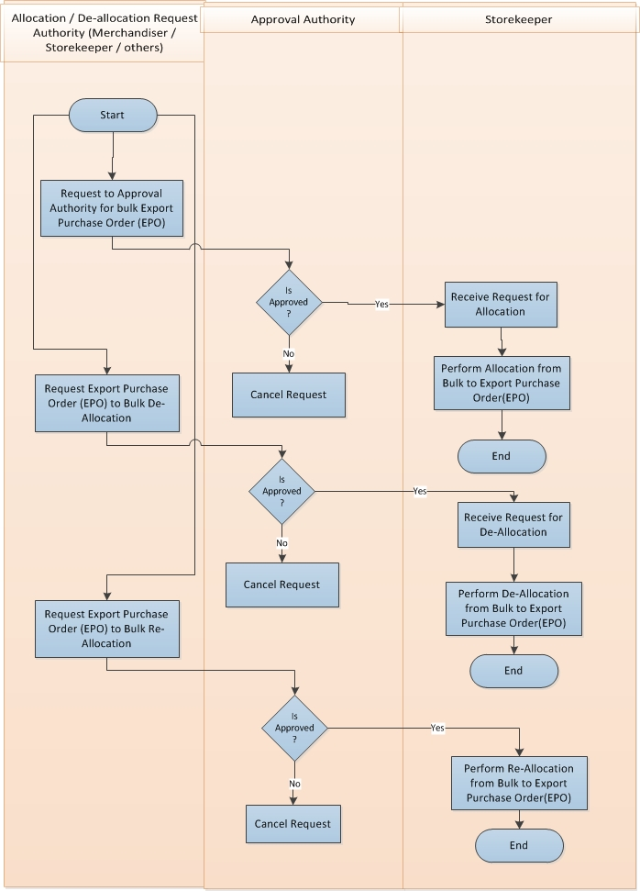

**Item Allocation, DE allocation and Reallocation Process Description**

* Allocation / De-allocation / Re-allocation request authority (Merchandiser / Storekeeper / Others) request to approval authority for bulk export purchase order (EPO).
* Approval Authority receives request for approval for bulk export purchase order (EPO)
* If Approval Authority is not approved then request is cancel.
* If Approval authority is approved then request to storekeeper for allocation
* Storekeeper receive request for allocation
* Storekeeper execute allocation from bulk to export purchase order (EPO)
* Allocation / De-allocation / Reallocation request authority (Merchandiser / Storekeeper / Others) request to approval authority for export purchase order (EPO) to bulk de-allocation
* Approval authority receive request for approval for export purchase order (EPO) to bulk de-allocation.
* If Approval authority is not approved then request is cancel
* If Approval authority is approved then request to storekeeper for de-allocation
* Storekeeper receive request for de-allocation
* Storekeeper execute de-allocation from bulk to export purchase order (EPO)
* Allocation / De-allocation / Reallocation request authority (Merchandiser / Storekeeper / Others) request to approval authority for export purchase order (EPO) to bulk re-allocation
* Approval authority receive request for approval for export purchase order (EPO) to bulk re-allocation.
* If Approval authority is not approved then request is cancel
* If Approval authority is approved then request to storekeeper for re-allocation
* Storekeeper receive request for re-allocation
* Storekeeper execute re-allocation from bulk to export purchase order (EPO)

## Issue Item Process

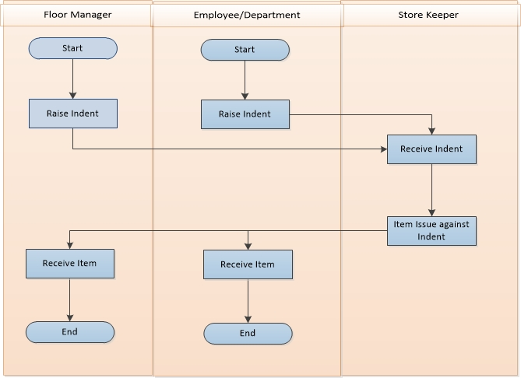

**Issue Item Process Description**

* Floor Manager or Employee / Department raise indent
* Storekeeper receive indent from Floor Manager or Employee / Department
* Storekeeper issue item to Floor Manager or Employee / Department against indent
* Floor Manager or Employee / Department receive issued item

## Issue Return Process

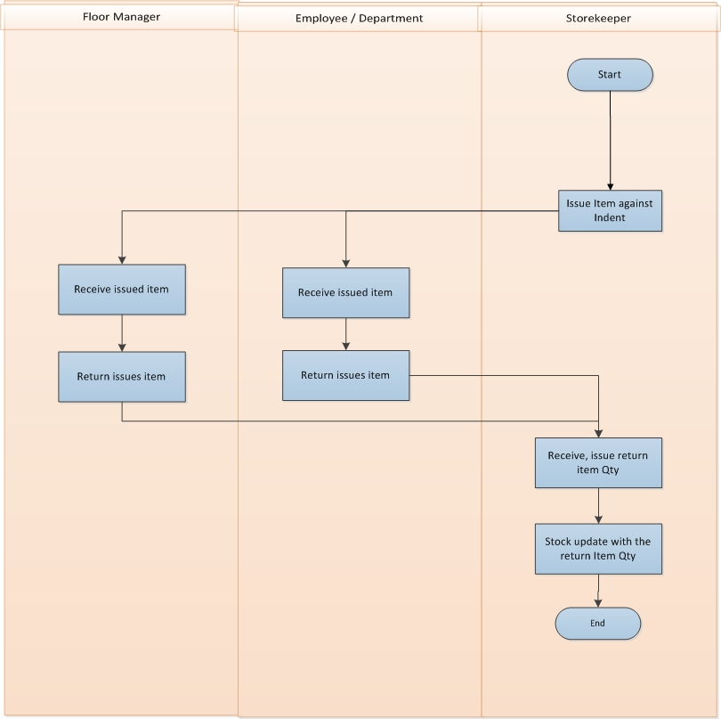

**Issue Return Process Description**

* Storekeeper issue item to Floor Manager or Employee / Department against indent
* Floor Manager or Employee / Department receive issued item
* Floor Manager or Employee / Department can return issued item if not use all item
* Storekeeper receive return item from Floor Manager or Employee / Department
* Storekeeper update stock with the return item

## Physical Inventory Process

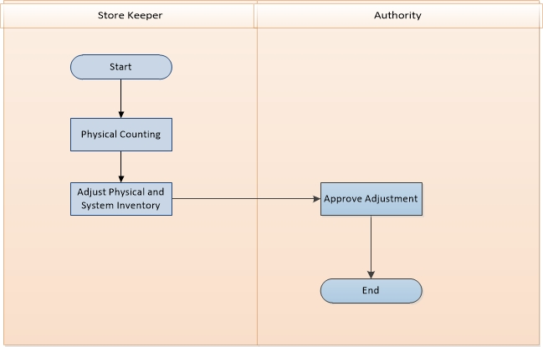

**Physical Inventory Process Description**

* Storekeeper will count item stock physically
* Storekeeper adjust the difference item stock in between system and practical
* Authority approve the item adjustment

## Item Adjustment Process

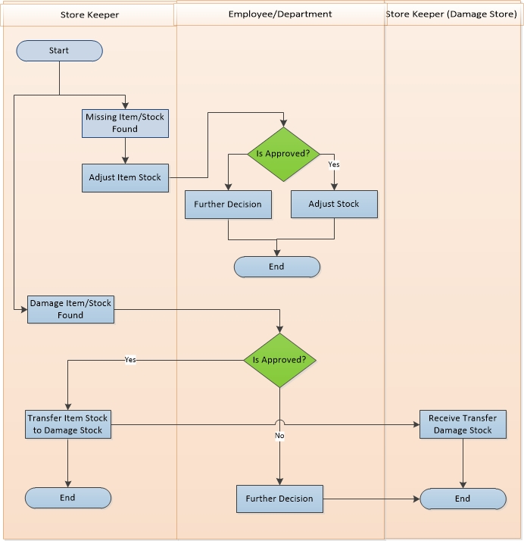

**Item Adjustment Process Description**

* Store Keeper adjusts item/stock depending on various conditions.
  + Missing item/stock:
    - If Store Keeper found any missing item/stock, Store Keeper sends adjustment request to Authority.
    - Authority takes decision depending on some condition. If approved the request then stock will adjust otherwise they take further decision.
  + Damage item/stock:
    - If Store Keeper found any damage item/stock, Store Keeper sends damage item transferto bad stock request to Authority.
    - Authority takes decision depending on some condition. If approved the request then accept the request and response accepted message to Store Keeper.
    - Store Keeper sends damage item to Store Keeper (Bad Stock) damage items stock.
    - If cancel the request then Authority takes further decision.

## Gate Pass Out Process

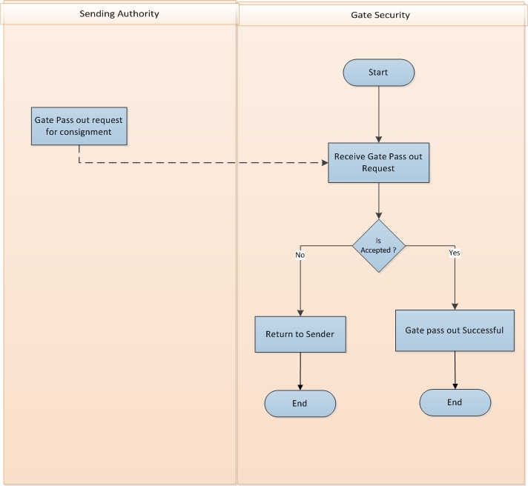

**Gate Pass Out Process Description**

* Sending Authority request for gate pass to send consignment outside
* Gate Security check the request
* If the consignment is accepted to pass the gate then gate pass will be successful
* If the consignment is not accepted to pass the gate then consignment will be returned to the sender

## Gate Pass In Process

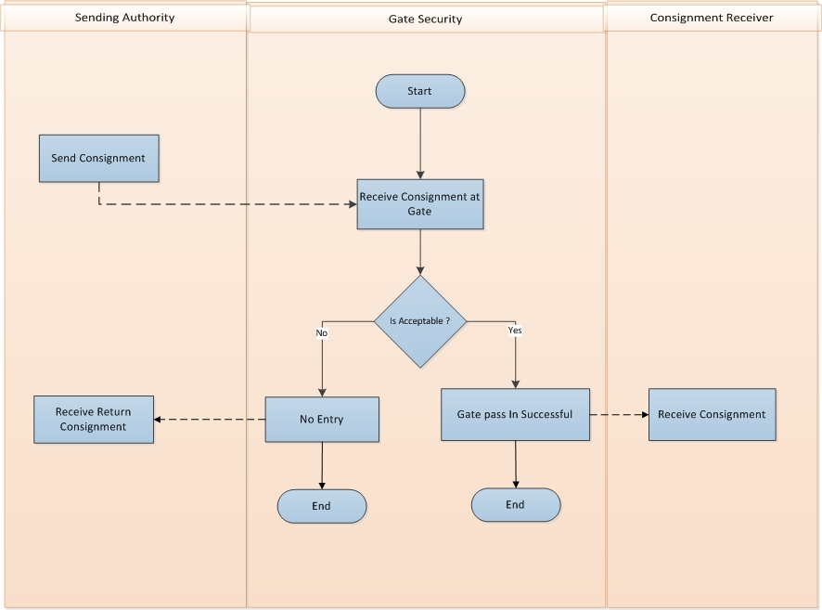

**Gate Pass In Process Description**

* Sending Authority send Consignment
* Gate Security check the consignment
* If the consignment is accepted to pass the gate then gate pass In will be successful
* Receiver will receive the goods inside the location
* If the consignment is not accepted to pass the gate then consignment will not get entered in Location
* Consignment will be returned to the Sender

# USE CASE Diagram

## Raise Indent Process

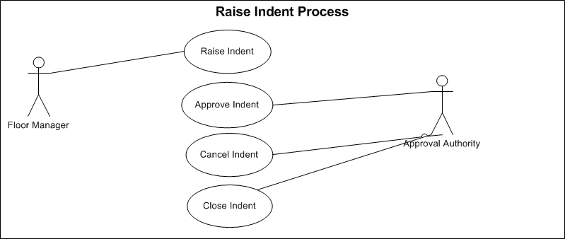

Fig: Raise indent

## Receive Goods:



Fig: Good receive process

## Receive Return Process:

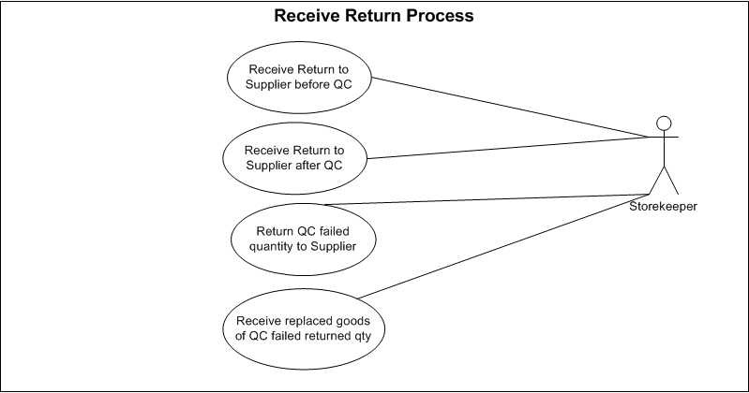

Fig: Receive return process

## QC Process

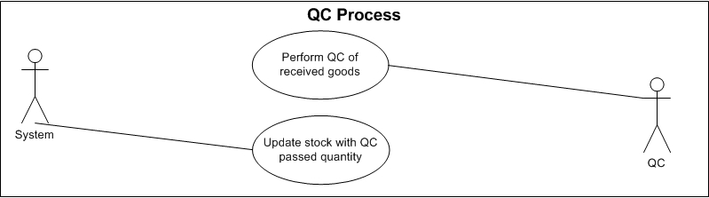

Fig: QC process

## Inventory Item Transfer Process

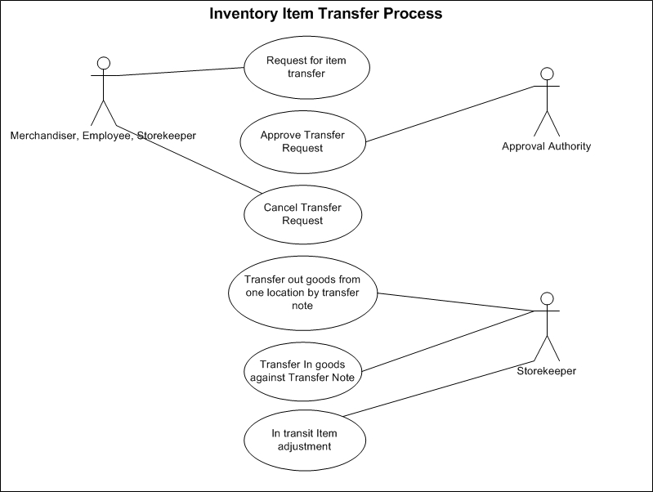

Fig: Inventory item transfer process

## Item Allocation, De-allocation and Reallocation Process

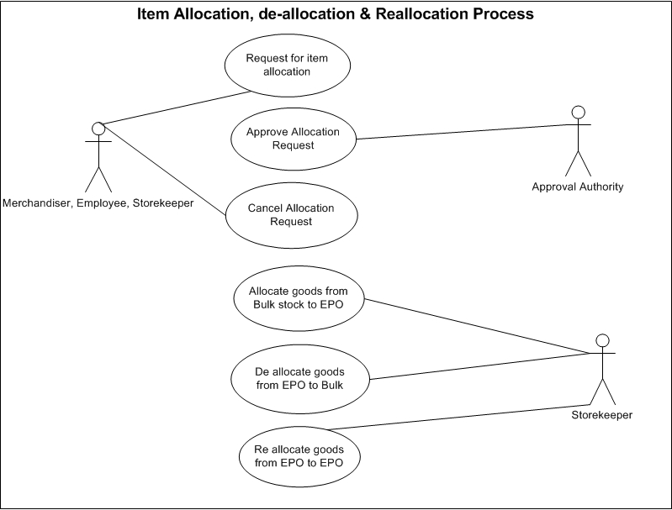

Fig: Item allocation, de-allocation and reallocation process

## Item Issue process

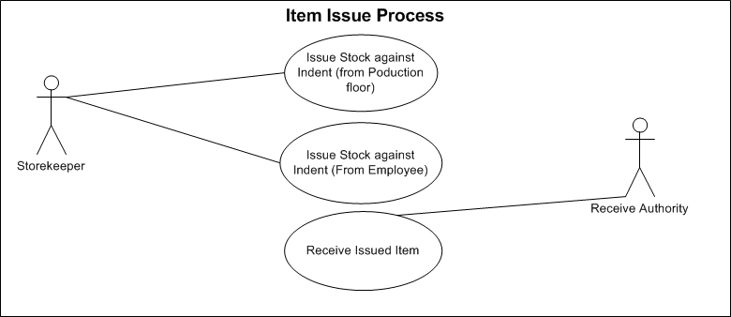

Fig: Item issue process

## Issue Return Process

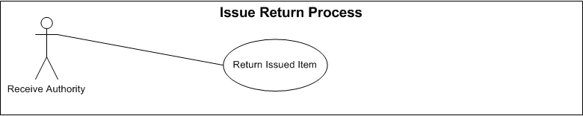

Fig: Issue return process

## Physical Inventory Process

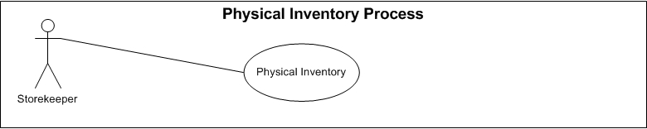

Fig: Physical Inventory Process

## Item Adjustment Process

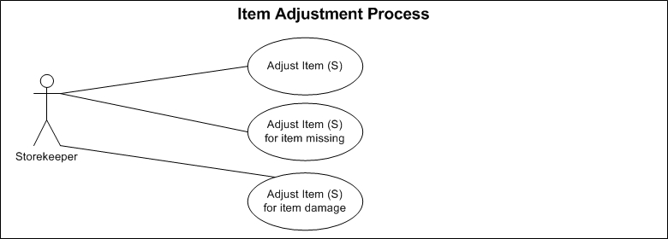

Fig: Item adjustment process

## Gate Pass Process



Fig: Gate Pass process

# USE CASE Details

## UC/INV/001/Raise Indent

|  |  |
| --- | --- |
| Use Case ID: UC/INV/001 | |
| Use Case Name**: Raise Indent** | |
| Created By: **GenWeb2 Ltd.** | Date Created: 13 October, 2015 |
| Actors: | * Floor Manager and Employee |
| Trigger: | * When Production floor needs any raw materials * When any Employee need any consumable items |
| Business Rule | * There are two types of indent.   + Indent for production raw material: This can be raised by floor manager only.   + Indent for general item: This can be raised by only employee. * Multiple items can exist in single Indent. * Indent will have the target store name * Indent can be seen by any users who have access to the Indent interface. |
| Description: | Whenever any item is require for production or general consumption then the related authority ask the require item(s) from Inventory authority through Indent. One Indent is for raw materials and another one id for general consumption |
| Frequency of Use | * Medium |
| Preconditions | * Item (s) must be exists in System. * Unit of Measurement must exists in System. |
| Post Conditions | * Appropriate message will be displayed after each entry being saved / updated. * Approval Authority will be notified for approval response. |
| Assumption | * N/A |
| Goal | Create Indent in system |
| Normal Flow | * Indent can be raised by floor manager for raw materials requires for Finished Goods production * Indent can be raised by any Employee of any department whenever any consumable items require * Indent Number will be system generated & configurable. * Indent Date would be populated with current date. * Based on user type   + Floor Manager: EPO number must have to be selected. Only materials declared in BOM will be available for selection purpose. Indent quantity can’t be more than balance quantity of BOM.   + Employee: If user type is employee then only General Item can be selected for Indent. For General Consumption Item Indent EPO no field will be disappeared. * Multiple items can exist in single Indent. * Indent will have the target store name. * UOM must be declared. Initially it will be populated with the default UOM but user may change it as require. * User can write necessary note in remarks. * Created by field would be auto loaded by the logging in use name. Its read only field. * Updated by field would be auto loaded by the logging in use name who is updating the Indent. It’s also read only field. |
| Alternate Flow | N/A |
| Exception | * Proper message should be displayed if Indent can’t be saved. * Proper message should be displayed if any master or dependent data is missing or not found. * Appropriate message should be displayed if mandatory fields are not filled. * Any system exception/Application exception should be handled centrally with proper user message during the page browse/save/update/view operations. |
| Cross Reference | * N/A |

## UC/INV/002/Edit/Modify Indent

|  |  |
| --- | --- |
| Use Case ID: UC/INV/002 | |
| Use Case Name**: Edit/Modify Indent** | |
| Created By: **GenWeb2 Ltd.** | Date Created: 13 October, 2015 |
| Actors: | * Floor Manager/Employee |
| Trigger: | * When any modification requires for any draft/saved Indent. |
| Business Rule | * Indent for “Production Raw Materials” or “General Consumption” can’t be switched. * Only Authorized user can edit/modify Indent. * Only draft/saved Indent(s) can be modified. * If Indent is not submitted then Edit/Modification can take place. * Modification can take place if there is any mistake in Indent. * Modification can take place if there is any changes in Indent. |
| Description: | If changes or modification requires for any raised and un submitted Indent then concern authority edit/modify that Indent. |
| Frequency of Use | Medium |
| Preconditions | * Indent must exist in System. * Indent must be at un-submitted state. |
| Post Conditions | * Appropriate message will be displayed after each entry being saved/ updated. * Will be available for edit/modify again. * Will be available for submit again |
| Assumption | * N/A |
| Goal | Adjust necessary changes in Indent |
| Normal Flow | * User can Update/Modify target Inventory * User Can Update/Modify Items/Quantity/Require Date/ UOM. * If the Indent is for “Production Raw Materials” then Items can be edit/modified in between declared Raw Materials (in BOM) for the selected EPO. * Remarks can be edited. * Created By can’t be modified * Updated by field would be auto loaded by the logging in use name who is updating the Indent. It’s also read only field. |
| Alternate Flow | * N/A |
| Exception | * Proper message should be displayed if no content is found while loading the project list. * Appropriate message should be displayed if mandatory fields are not filled. * Any system exception/application exception should be handled centrally with proper user message during the page browse/save/update/view operations. |
| Cross Reference | * Use Case ID: UC/INV/001 |

## UC/INV/003/ Approve Indent

|  |  |
| --- | --- |
| Use Case ID: UC/INV/003 | |
| Use Case Name**: Approve Indent** | |
| Created By: **GenWeb2 Ltd.** | Date Created: 13 October, 2015 |
| Actors: | * Indent Approval Authority |
| Trigger: | * When any raised Indent needs approval for further action |
| Business Role | * Approved Indent can’t be modified. |
| Description: | After raising Indent by the Production Floor Manager/Employee it needs to be approved by the approval authority for further processing. |
| Frequency of Use | * Medium |
| Preconditions | * Indent must exist in system and must be submitted. |
| Post Conditions | * Indent will be approved or rejected. * Approved Indent will be available to Inventory for further action. |
| Assumption | * Approval Authority get notification for pending approval of Indent (s). |
| Goal | Approve Indent for further use. |
| Normal Flow | * When any indent has been created Approval Authority will get notification for approval action. * Only authorized user will have the authority to approve/reject the submitted indent. |
| Alternate Flow | * N/A |
| Exception | * Proper message should be displayed if no content is found while loading the Indent. * Appropriate message should be displayed if approval not possible. * Any system exception/application exception should be handled centrally with proper user message during the page browse/save/update/view operations. |
| Cross Reference | * Use Case ID: UC/INV/001 |

## UC/INV/004/Cancel Indent

|  |  |
| --- | --- |
| Use Case ID: UC/INV/004 | |
| Use Case Name**: Cancel Indent** | |
| Created By: **GenWeb2 Ltd.** | Date Created: 13 October, 2015 |
| Actors: | * Production Floor Authority, Employee, Super Admin |
| Trigger: | When any raised Indent canceled by the indenter |
| Business Role | * Only Authorized authority can cancel Indent. * Indent Can’t be cancelled if indentor has already received item(s) against the Indent |
| Description: | If any Indent get Invalid then the authority/indentor cancel that Indent |
| Frequency of Use | * Low |
| Preconditions | * Indent must exists. * No Inventory issue happen against the Indent |
| Post Conditions | * Indent will be cancelled. * If the Cancel Indent is for “Production raw Material” then the Cancelled item &qty will be added in balance to raise Indent for that particular EPO. * No further business action will take place after cancellation of Indent. * Indent will not be available to Issue Inventory Item against it. * Indent will not be available to create Purchase Requisition. * Cancelled Indent will not be appeared for raising Purchase Requisition anymore. * Cancelled Indent will not be appeared for issuing Inventory Item. |
| Assumption | * N/A |
| Goal | Cancel any Indent |
| Normal Flow | * Indent can only be cancelled by the same user who have created that indent or by the super admin. * Both Approved & unapproved Indent can be cancelled. * If any purchase Requisition was already created against any indent in that case Purchase Requisition must have to be cancelled then only Indent can be declared as cancelled. |
| Alternate Flow | * N/A |
| Exception | * Proper message should be displayed if no content is found while loading the Indent. * Appropriate message should be displayed if Cancellation not possible. * Any system exception/application exception should be handled centrally with proper user message during the page browse/save/update/view operations. |
| Cross Reference | * Use Case ID: UC/INV/001 |

## UC/INV/005/Close Indent

|  |  |
| --- | --- |
| Use Case ID: UC/INV/005 | |
| Use Case Name**: Close Indent** | |
| Created By: **GenWeb2 Ltd.** | Date Created: 13 October, 2015 |
| Actors: | * Floor Manager, Employee or Super Admin |
| Trigger: | When any raised Indent need to be closed before completing the full operation. |
| Business Role | * Indent can only be declared as Close by the same user who has created that indent. * Indent is already approved. * Indent cannot be cancelled. * Inventory issue has already been triggered against the Indent (Partially) * No Inventory issue will happen against the Indent for pending Items(Ex: Indent is having 1000 quantity and Inventory has issued 400 quantity and somehow it has been decided that no Inventory issue will happen for the balance 600 quantity as it is not require for the Indenter anymore. In that case Indent can’t be cancelled as already Inventory issue has taken place, On the other side it can’t display 600 quantity as balance for yet to Issue from Inventory so Close statement of any Indent will keep the existing Inventory issue active (which is 400 is this case) and no Indent quantity will be displayed as pending (which is 600 is this case)). |
| Description: | If any Indent has some pending Quantity to issue from Inventory but decision has been taken that it will not be executed anymore or not required in that case the Indent will be declared as ‘Closed’ so that it will not display the pending item Indent quantity for Inventory issue or Create Purchase Order anymore. |
| Frequency of Use | * Low |
| Preconditions | * Indent must exists. * Indent must be approved. |
| Post Conditions | * Indent will be state as closed. * Already Issued item (s) from Inventory against the Indent will remain same. * Item can’t be issue anymore against the Indent. |
| Assumption | * N/A |
| Goal | Close any Indent. |
| Normal Flow | * The user will close the indent and put remarks for closing the indent. |
| Alternate Flow | * N/A |
| Exception | * Proper message should be displayed if no content is found while loading the Indent. * Appropriate message should be displayed if Indent Closing not possible. * Any system exception/Application exception should be handled centrally with proper user message during the page browse/save/update/view operations. |
| Cross Reference | * Use Case ID: UC/INV/001 |

## UC/INV/006/Receive Goods in Inventory

|  |  |
| --- | --- |
| Use Case ID: UC/INV/006 | |
| Use Case Name**: Receive Goods in Inventory** | |
| Created By: **GenWeb2 Ltd.** | Date Created: 13 October, 2015 |
| Actors: | * Storekeeper |
| Trigger: | * When Inventory authority receives goods against Purchase order, commercial invoice & independently |
| Business Role | * Goods can be received against any purchase order or commercial invoice or independently |
| Description: | * Supplier delivers goods to Inventory as per the given Purchase Order or Commercial Invoice. Storekeeper receive delivered goods as per the documents. |
| Frequency of Use | * Medium |
| Preconditions | * Approved Purchase Order or Commercial Invoice issued to Supplier. * Inventory Location must exist to receive the goods. |
| Post Conditions | * Item(s) will be received against the Supplier Purchase Order or Commercial Invoice or independently. * Received goods will be automatically available for QC process. * QC authority will receive notification for pending QC |
| Assumption | * N/A |
| Goal | Receive Delivered Items from Supplier against the Purchase Order |
| Normal Flow | * Inventory Authority receives goods based on “Receive Against” selection. There are three options   + Against Purchase Order   + Against Commercial Invoice   + Independent * If Inventory Authority receives against Purchas Order then Balance to receive items will be populated from the selected Purchase Order. * PO no must be selected if any receive is against Purchase Order * If all the populated item(s) are not require against the selected PO than user will keep the receivable item(s) and will delete the other from the grid. Deleted item(s) and qty will be available to receive at the next time * User may change to the current receivable quantity(where it has been populated with the balance qty against the selected PO) * If Inventory Authority receives against Commercial Invoice then Balance to receive items will be populated from the selected Commercial Invoice. * CI no must be selected if any receive is against Commercial Invoice * If all the populated item(s) are not require against the selected CI than user will keep the receivable item(s) and will delete the other from the grid. Deleted item(s) and qty will be available to receive at the next time * User may change to the current receivable quantity(where it has been populated with the balance qty against the selected CI) * If Inventory Authority receives against Independent that means he/she can receive anything without any reference * PO No/ CI No option will be disappeared if receive is against Independent. * For receive against Independent user will select item, qty and UOM as needed. * “GRN No” is a system generated number which stands for: Goods Receive Note number. The logic behind this number is: “**GRN/Date/3 Digit Serial”** * GRN date will be populated with the current date. It can be changed to back date only. * Inventory will be selected where the logging in user have access. If there is Multiple Inventory accessible for that user than the user will select the respective Inventory where the items will be received. * Chalan No is the reference Number from Supplier comes with the consignment. * Remarks is a free text to keep any note related to that receive |
| Alternate Flow | * N/A |
| Exception | * Proper message should be displayed if Inventory receive transaction cannot be saved. * Proper message should be displayed if any master or dependent data is missing or not found. * Appropriate message should be displayed if mandatory fields are not filled. * Any system exception/Application exception should be handled centrally with proper user message during the page browse/save/update/view operations. |
| Cross Reference | * Use Case ID: UC/PRO/010 |

## UC/INV/007/Receive Return to Supplier before QC

|  |  |
| --- | --- |
| Use Case ID: UC/INV/007 | |
| Use Case Name**:** Receive Return to Supplier before QC | |
| Created By: **GenWeb2 Ltd.** | Date Created: 13 October, 2015 |
| Actors: | * Storekeeper |
| Trigger: | * When inventory received items needs to return to supplier before QC process. |
| Business Rule | * Inventory received goods will not move to QC process or will not be added to Inventory stock |
| Description: | Supplier delivered goods to storekeeper as per the Purchase Order Storekeeper receives goods accordingly but If there is any mismatch then storekeeper return the goods to supplier |
| Frequency of Use | * Low |
| Preconditions | * Supplier Purchase Order Must exist * Inventory receive must exist against the Purchase Order |
| Post Conditions | * Received Return item quantity will not flow to QC process. * Received Return item quantity will be added in pending Purchase Order delivery quantity * This quantity will be available to receive again from Supplier |
| Assumption | * N/A |
| Goal | Return goods to Supplier after Inventory receive and before QC process |
| Normal Flow | * Return date will be loaded with the current date but can be changed as require. * Return date can’t be lesser than the receive date. * If there is multiple Receive Date (GRN) for any PO then system will cross check with the earliest date to validate. * Return can be against PO (Supplier Purchase Order). * If return is against GRN (Goods Receive Note) then system will find the PO against the selected GRN and will manage the return information. * Return stage must be selected as ‘Before QC”. * In data grid PO/GRN will be loaded as per the selection of Return By. * QC No column is not require for return before QC so it will be read only or disappeared. * Item from the received list against the PO/GRN can be selected. There will be option to select all items. * System will load the receive Qty against the selected PO/GRN item (s). If it is GRN, then the receive qty will be of that GRN, if it is PO, then the receive qty will be the sum of the GRN was made against the selected PO. * Return qty can’t be greater than the GRN qty or sum of GRN qty against PO. * Base UOM will be loaded for the selected PO/GRN. * If there is different type of UOM for different Type of item(s) then system will allow to define the UOM. * Remarks is a free text field to keep any note while performing Return Process action * After successful action return item qty will be added to PO as pending. |
| Alternate Flow | * N/A |
| Exception | * Proper message should be displayed if receive return to supplier cannot be saved. * Proper message should be displayed if any master or dependent data is missing or not found. * Appropriate message should be displayed if mandatory fields are not filled. * Any system exception/Application exception should be handled centrally with proper user message during the page browse/save/update/view operations. |
| Cross Reference | * Use Case ID: UC/INV/006 |

## UC/INV/008/Purchase Order Cancellation for Received Return Items – (Procurement)

|  |  |
| --- | --- |
| Use Case ID: UC/INV/008 | |
| Use Case Name: Purchase Order Cancellation for Returned Items | |
| Created By: **GenWeb2 Ltd.** | Date Created: 13 October, 2015 |
| Actors: | * Procurement Authority |
| Trigger: | * When Purchase order need to be canceled for receive returned items |
| Business Rule | * Supplier deliver goods to Inventory against the given Purchase Order * Inventory Authority receive the goods against Purchase Order * Inventory authority return the goods to supplier for any reason * Inventory received goods will not move to QC process or will not be added to Inventory stock * Procurement Authority cancel the Purchase Order for the received returned quantity. |
| Description: | Inventory authority returned receive goods against purchase order and cancel purchase order also for the returned items. |
| Frequency of Use | * Medium |
| Preconditions | * + - * Supplier Purchase Order Must exist       * Inventory must receive goods       * Inventory return goods to Supplier |
| Post Conditions | * + - * Appropriate message will be displayed after successfully cancellation of Purchase Order in System.       * Purchase Order receive return quantity will not be able to receive again from Supplier |
| Assumption | * N/A |
| Goal | To Cancel Supplier Purchase Order for Received Return items |
| Normal Flow | * Storekeeper receives goods against supplier purchase order * Storekeeper return the received goods to supplier * Procurement authority cancel the related purchase order |
| Alternate Flow | * N/A |
| Exception | * + - * Proper message should be displayed if Purchase order cancellation for returned items can’t be saved. * Proper message should be displayed if any master or dependent data is missing or not found. * Appropriate message should be displayed if mandatory fields are not filled. * Any system exception/Application exception should be handled centrally with proper user message during the page browse/save/update/view operations. |
| Cross Reference | * Use Case ID: UC/INV/006 * Use Case ID: UC/INV/007 |

## UC/INV/009/Perform QC of receive goods

|  |  |
| --- | --- |
| Use Case ID: UC/INV/009 | |
| Use Case Name**: Perform QC of received goods** | |
| Created By: **GenWeb2 Ltd.** | Date Created: 13 October, 2015 |
| Actors: | * QC |
| Trigger: | * When execute the QC process |
| Business Rule | * + - * Inventory Authority receive the goods against Purchase Order or Commercial Invoice or Independently |
| Description: | QC inspector goes for QC process of the received goods. Only QC passed quantity will be updated to the stock and failed quantity will be returned to supplier. |
| Frequency of Use | * Medium |
| Preconditions | * Inventory must receive goods |
| Post Conditions | * + - * Only QC passed quantity will be updated in the target stock       * QC failed quantity will be rejected |
| Assumption | * N/A |
| Goal | To record QC data and update the stock with only the QC passed quantity. |
| Normal Flow | * Quality Inspector perform QC process of the received goods * Only QC passed quantity will be updated the stock * QC Number is a system generated number. “**QC/Date/GRN/3 Digit Serial**” * QC Date will be populated with the current date but user can change it as require. * QC date can’t be lesser than the GRN date. * Only those GRN where it is pending for QC (Balance qty) will be available here to select * QC Inspector will be auto populated by the logged in user Employee name. * Inventory will be available to select based on user access. * Data grid will be auto populated based on GRN and Inventory. * Remarks is a free text to keep note for the QC process |
| Alternate Flow | * N/A |
| Exception | * + - * Proper message should be displayed if QC can’t be saved. * Proper message should be displayed if any master or dependent data is missing or not found. * Appropriate message should be displayed if mandatory fields are not filled. * Any system exception/Application exception should be handled centrally with proper user message during the page browse/save/update/view operations. |
| Cross Reference | * Use Case ID: UC/INV/006 |

## UC/INV/010/Receive Return to Supplier after QC

|  |  |
| --- | --- |
| Use Case ID: UC/INV/010 | |
| Use Case Name**: Receive Return to Supplier after QC** | |
| Created By: **GenWeb2 Ltd.** | Date Created: 13 October, 2015 |
| Actors: | * Storekeeper |
| Trigger: | * When inventory received items needs to return to supplier. |
| Business Rule | * QC failed qty will be returned. |
| Description: | Supplier delivered goods to storekeeper as per the Purchase Order Storekeeper receives goods accordingly but If there is any mismatch found during QC process then storekeeper returns the goods to supplier |
| Frequency of Use | * Low |
| Preconditions | * Supplier Purchase Order must exist * Inventory receive must exist against the Purchase Order * QC process must exist |
| Post Conditions | * QC passed quantity will be revised in system. * Returned item quantity will be added in pending Purchase Order delivery quantity * This quantity will be available to receive again from Supplier |
| Assumption | * N/A |
| Goal | Return goods to Supplier after Inventory receive and after QC process |
| Normal Flow | * Return date will be loaded with the current date but can be changed as require. * Return date can’t be lesser than the receive date. * If there is multiple Receive Date (GRN) for any PO then system will cross check with the earliest date to validate. * Return can be against PO (Supplier Purchase Order). * If return is against GRN (Goods Receive Note) then system will find the PO against the selected GRN and will manage the return information. * Return stage must be selected as ‘QC failed item”. * In data grid PO/GRN will be loaded as per the selection of Return By. * QC Number has to be selected from the pending list. All QC against any GRN/PO can be also selected; in that case sum of QC details will be loaded in that row. * Item from the received list against the QC number can be selected. There will be option to select all items. * System will load the QC failed Qty against the selected QC Number item (s). * Return qty can’t be greater than the QC failed qty. * Base UOM will be loaded for the selected PO/GRN. * If there is different type of UOM for different Type of item(s) then system will allow to define the UOM. * Remarks is a free text field to keep any note while performing Return Process action. |
| Alternate Flow | * N/A |
| Exception | * Proper message should be displayed if receive return to supplier cannot be saved. * Proper message should be displayed if any master or dependent data is missing or not found. * Appropriate message should be displayed if mandatory fields are not filled. * Any system exception/Application exception should be handled centrally with proper user message during the page browse/save/update/view operations. |
| Cross Reference | * Use Case ID: UC/INV/006 * Use Case ID: UC/INV/009 |

## UC/INV/011/ Update stock with QC passed quantity

|  |  |
| --- | --- |
| Use Case ID: UC/INV/011 | |
| Use Case Name**: Update stock with QC passed quantity** | |
| Created By: **GenWeb2 Ltd.** | Date Created: 13 October, 2015 |
| Actors: | * System |
| Trigger: | * When received goods pass the QC process |
| Business Role | * Storekeeper receives goods from Supplier * Quality inspector perform the quality check process * System update the stock only by the QC passed quantity |
| Description: | QC authority execute the QC process of the receive goods and update the stock only by the qc passed quantity |
| Frequency of Use | * Medium |
| Preconditions | * QC process of the received goods |
| Post Conditions | * Appropriate message will be displayed after successfully update the stock. |
| Assumption | * N/A |
| Goal | To update the inventory stock by the QC passed quantity only |
| Normal Flow | * + - * Quality Inspector perform the QC process       * System will update the stock only by the QC passed quantity |
| Alternate Flow | * N/A |
| Exception | * Proper message should be displayed if stock can’t be saved. * Proper message should be displayed if any master or dependent data is missing or not found. * Appropriate message should be displayed if mandatory fields are not filled. * Any system exception/Application exception should be handled centrally with proper user message during the page browse/save/update/view operations. |
| Cross Reference | * Use Case ID: UC/INV/009 |

## UC/INV/012/ Return QC Failed Quantity to Supplier – Duplicate with 5.10

|  |  |
| --- | --- |
| Use Case ID: UC/INV/012 | |
| Use Case Name**: Return QC failed quantity to Supplier** | |
| Created By: **GenWeb2 Ltd.** | Date Created: 13 October, 2015 |
| Actors: | * Storekeeper |
| Trigger: | * When received goods fails to pass the QC process |
| Business Role | * Quality Inspector perform the QC process for the received goods * QC failed items goes back to Supplier |
| Description: | QC authority execute the QC process in the received goods and returned QC failed quantity to supplier |
| Frequency of Use | * Medium |
| Preconditions | * QC process have QC failed quantity |
| Post Conditions | * Appropriate message will be displayed after successfully failed goods returned to supplier. |
| Assumption | * N/A |
| Goal | To return QC failed item(s) to Supplier |
| Normal Flow | * + - * Storekeeper receives goods from Supplier       * Quality Inspector perform quality check process       * QC failed item(s) gets back to supplier |
| Alternate Flow | * N/A |
| Exception | * Proper message should be displayed if QC failed goods returned can’t be saved. * Proper message should be displayed if any master or dependent data is missing or not found. * Appropriate message should be displayed if mandatory fields are not filled. * Any system exception/Application exception should be handled centrally with proper user message during the page browse/save/update/view operations. |
| Cross Reference | * N/A |

## UC/INV/013/ Order Cancellation for QC failed items/Qty – (Procurement)

|  |  |
| --- | --- |
| Use Case ID: UC/INV/013 | |
| Use Case Name**: Order Cancellation for QC failed items/Qty** | |
| Created By: **GenWeb2 Ltd.** | Date Created: 13 October, 2015 |
| Actors: | * Procurement/Authority |
| Trigger: | * When Purchase order need to be canceled for QC failed items |
| Business Rule | * Supplier deliver goods to Inventory against the given Purchase Order * Inventory Authority receive the goods against Purchase Order * Authority execute QC process of receive goods * Procurement Authority cancel the Purchase Order for the failed QC goods |
| Description: | Inventory authority canceled purchase order quantity of the QC failed goods. |
| Frequency of Use | * Medium |
| Preconditions | * Supplier Purchase Order Must exist * Inventory must receive goods from supplier * Quality inspector perform Quality Check process |
| Post Conditions | * Appropriate message will be displayed after successfully Order Cancellation for the QC failed item(s) * Purchase Order will be canceled for the QC failed quantity. |
| Assumption | * N/A |
| Goal | To cancel the Purchase Order for the QC failed Item(s) or quantity |
| Normal Flow | * + - * Receive goods against Purchase Order       * Perform QC process       * Cancel purchase order for the QC failed item(s) or quantity |
| Alternate Flow | * N/A |
| Exception | * Proper message should be displayed if Purchase order cancellation for failed QC items can’t be saved. * Proper message should be displayed if any master or dependent data is missing or not found. * Appropriate message should be displayed if mandatory fields are not filled. * Any system exception/Application exception should be handled centrally with proper user message during the page browse/save/update/view operations. |
| Cross Reference | * Use Case ID: UC/INV/009 |

## UC/INV/014/ Receive replaced goods of QC failed returned qty

|  |  |
| --- | --- |
| Use Case ID: UC/INV/014 | |
| Use Case Name**: Receive replaced goods of QC failed returned qty** | |
| Created By: **GenWeb2 Ltd.** | Date Created: 13 October, 2015 |
| Actors: | * Storekeeper |
| Trigger: | * When storekeeper receives replaced goods from Supplier against the QC failed returned goods |
| Business Role | * Storekeeper return the QC failed quantity to supplier * Supplier deliver replaced goods to Inventory against the Qc failed quantity * Storekeeper receives the replaced goods against the QC failed return quantity from Supplier |
| Description: | Inventory authority receive replaced goods of QC failed goods from Supplier. |
| Frequency of Use | * Medium |
| Preconditions | * QC process done * QC failed goods has been returned to Supplier |
| Post Conditions | * Appropriate message will be displayed after successfully receive replaced goods from supplier against the QC failed quantity. |
| Assumption | * N/A |
| Goal |  |
| Normal Flow | * + - * Perform QC process for the received goods       * Return the QC failed quantity to Supplier       * Receive replaced goods from supplier against the QC failed quantity as regular receive goods against PO |
| Alternate Flow | * N/A |
| Exception | * Proper message should be displayed if replaced goods receive can’t be saved. * Proper message should be displayed if any master or dependent data is missing or not found. * Appropriate message should be displayed if mandatory fields are not filled. * Any system exception/Application exception should be handled centrally with proper user message during the page browse/save/update/view operations. |
| Cross Reference | * Use Case ID: UC/INV/009 |

## UC/INV/015/ Request for Item Transfer

|  |  |
| --- | --- |
| Use Case ID: UC/INV/015 | |
| Use Case Name**: Request for Item Transfer** | |
| Created By: **GenWeb2 Ltd.** | Date Created: 13 October, 2015 |
| Actors | * Merchandiser * Employee * Storekeeper |
| Trigger | * When Merchandiser, Employee, Store Keeper wants to transfer items. |
| Business Rule | * Transfer Request Authority (Merchandiser/Storekeeper/Others) sends request to Approval Authority for item transfer. * Approval Authority receive the transfer request |
| Description | Transfer Request Authority (Merchandiser/Storekeeper/Others) create inventory item transfer request as per requirement |
| Frequency of Use | * Medium (Regularly) |
| Preconditions | * Prepares a list for transferring item. |
| Post Conditions | * Verify the request with necessary information. |
| Assumption | * N/A |
| Goal | To create inventory item transfer request |
| Normal Flow | * Transfer Request Authority prepares a list of item (s) for transfer. * Transfer Request Authority sends item transfer request to Approval Authority. * Approval Authority receives transfer request and verify the request with necessary information. * This process will be managed manually. |
| Alternate Flow | * N/A |
| Exception | * N/A |
| Cross Reference | * N/A |

## UC/INV/016/ Approve Transfer Request

|  |  |
| --- | --- |
| Use Case ID: UC/INV/016 | |
| Use Case Name**: Approve Transfer Request** | |
| Created By: **GenWeb2 Ltd.** | Date Created: 13 October, 2015 |
| Actors | * Approval Authority |
| Trigger | * When Transfer Request Authority (Merchandiser / Storekeeper / others) sends request for item transfer. |
| Business Rule | * Approval Authority receives request from Transfer Request Authority with list of item and other necessary information. * If approved then request to concerned storekeeper to transfer the item and update the stock as well. |
| Description | Approval Authority receives request from Transfer Request Authority with list of item and other necessary information. If approved then request to concerned storekeeper to transfer the item and update the stock as well. |
| Frequency of Use | * Medium |
| Preconditions | * Must have item transfer request. |
| Post Conditions | * After taking approval decision system must have reflect the decision. |
| Assumption | * N/A |
| Goal | * To approve inventory item transfer request |
| Normal Flow | * Approval Authority receives request from Transfer Request Authority with list of item and other necessary information. * If approved then request to concerned storekeeper to transfer the item and update the stock as well. * This process will be managed manually. |
| Alternate Flow | * N/A |
| Exception | * N/A |
| Cross Reference | * Use Case ID: UC/INV/015 |

## UC/INV/017/ Cancel Transfer Request

|  |  |
| --- | --- |
| Use Case ID: UC/INV/017 | |
| Use Case Name**: Cancel Transfer Request** | |
| Created By: **GenWeb2 Ltd.** | Date Created: 13 October, 2015 |
| Actors | * Approval Authority |
| Trigger | * When Approval Authority takes decision to cancel the request. |
| Business Rule | * Approval Authority receive request from Transfer Request Authority with item list with necessary information. * If Approval Authority decides not to approve the Transfer Request then cancel decision comes. * After cancel the request Approval Authority ends the request process here. |
| Description | Approval Authority receive request from Transfer Request Authority with item list with necessary information. If Approval Authority decides not to approve the Transfer Request then cancel decision comes. After cancel the request Approval Authority ends the request process here. |
| Frequency of Use | * Medium (Regularly) |
| Preconditions | * Approval Authority must takes decision not to approve the request. |
| Post Conditions | * Process must be end. |
| Assumption | * N/A |
| Goal | * T cancel the inventory item transfer request |
| Normal Flow | * Approval Authority receive request from Transfer Request Authority with item list with necessary information. * If Approval Authority decides not to approve the Transfer Request then cancel decision comes. * After cancel the request Approval Authority ends the request process here. * This process will be managed manually. |
| Alternate Flow | * N/A |
| Exception | * N/A |
| Cross Reference | * Use Case ID: UC/INV/015 |

## UC/INV/018/ Transfer out goods from one location by transfer note

|  |  |
| --- | --- |
| Use Case ID: UC/INV/018 | |
| Use Case Name**: Transfer Out Goods from One Location by Transfer Note** | |
| Created By: **GenWeb2 Ltd.** | Date Created: 13 October, 2015 |
| Actors | * Approval Authority * Storekeeper |
| Trigger | * When Approval Authority approves the Item Transfer Request. |
| Business Rule | * If item transfer request approved then request to transfer list of items to concerned storekeeper/inventory. * Item transfer request from one inventory concerned person to another inventory concerned person. |
| Description | If item transfer request approved then request to transfer list of items to concerned storekeeper/inventory. Item stock will be transferred instantly and physical stock will be adjusted at the end of the day |
| Frequency of Use | * Medium |
| Preconditions | * Must have approval of the item transfer request. |
| Post Conditions | * Item will be transfer from the source location to request location |
| Assumption | * N/A |
| Goal | To execute transfer as per the transfer request |
| Normal Flow | * If item transfer request approved then request to transfer list of items to concerned storekeeper/inventory. * Item will be transferred from souce location to destination location * Transfer No is a System generated number. Logic is “Month/serial” * Transfer Date will be populated as current date but user can change it as require. * Source Inventory will be available to select based on user access. * Destination Inventory will be available to select based on user access. * Product & description will be selected based on variant. * Current stock of the selected item in Source Inventory will be populated in Source inventory Stock * User will put the require transfer qty in Transfer qty column. * Transfer qty can’t be greater than the source Inventory Stock qty. * UOM will be loaded with the base but if needed user may change it and Source Inventory Stock and Transfer Qty will be changed based on UOM conversion. * Remarks is a free text to keep any note for Inventory item transfer * Transfer Request By have to select * Transfer by will be auto populated by the logged in user. |
| Alternate Flow | * N/A |
| Exception | * Proper message should be displayed if inventory transfer can’t be saved. * Proper message should be displayed if any master or dependent data is missing or not found. * Appropriate message should be displayed if mandatory fields are not filled. * Any system exception/Application exception should be handled centrally with proper user message during the page browse/save/update/view operations. |
| Cross Reference | * Use Case ID: UC/INV/015 |

## UC/INV/019/ Request for item allocation

|  |  |
| --- | --- |
| Use Case ID: UC/INV/019 | |
| Use Case Name**: Request for Item Allocation** | |
| Created By: **GenWeb2 Ltd.** | Date Created: 13 October, 2015 |
| Actors | * Merchandiser * Employee * Storekeeper * Others |
| Trigger | * When Merchandiser, Employer, Storekeeper needs allocated item stock |
| Business Rule | * Merchandiser / Storekeeper / Others request for the item stock allocation as require * Item stock allocation request moves to approval authority |
| Description | Merchandiser / Storekeeper / Others request for the item stock Allocation / De-allocation / Re-allocation as require in between Bulk and EPO stock allocation. |
| Frequency of Use | * Medium |
| Preconditions | * When Merchandiser, Employer, Storekeeper needs item stock allocation |
| Post Conditions | * Item stock allocation request moves to approval authority |
| Assumption | * N/A |
| Goal | * To create Allocation/De-allocation/Re-allocation request |
| Normal Flow | * Allocation / De-allocation / Re-allocation request Authority create allocation request * Allocation request moves to Approval authority * This process will be managed manually. |
| Alternate Flow | * N/A |
| Exception | * N/A |
| Cross Reference | * N/A |

## UC/INV/020/Approve Allocation Request

|  |  |
| --- | --- |
| Use Case ID: UC/INV/020 | |
| Use Case Name**: Approve Allocation Request** | |
| Created By: **GenWeb2 Ltd.** | Date Created: 13 October, 2015 |
| Actors | * Approval Authority |
| Trigger | * When Merchandiser, Employer, Storekeeper request for item stock allocation/de-allocation/re-allocation |
| Business Rule | * Approval Authority receives request for item stock allocation * After approval of the request it goes to storekeeper for further action |
| Description | Approval Authority receives request for item stock allocation/De-allocation/Re-allocation, after approval of the request it goes to storekeeper for further action |
| Frequency of Use | * Medium |
| Preconditions | * Request for item stock allocation |
| Post Conditions | * Storekeeper takes necessary steps to execute the request |
| Assumption | * N/A |
| Goal | * To approve the allocation request |
| Normal Flow | * Approval Authority receives request for item stock allocation/de-allocation/re-allocation * After approval allocation request moves to storekeeper for further action * This process will be managed manually. |
| Alternate Flow | * N/A |
| Exception | * N/A |
| Cross Reference | * Use Case ID: UC/INV/019 |

## UC/INV/021/Cancel Allocation Request

|  |  |
| --- | --- |
| Use Case ID: UC/INV/021 | |
| Use Case Name**: Cancel Allocation Request** | |
| Created By: **GenWeb2 Ltd.** | Date Created: 13 October, 2015 |
| Actors | * Storekeeper |
| Trigger | * If item stock allocation not require anymore |
| Business Rule | * Request for item stock allocation * Request moves to approval authority * Request cancellation by the requested person. |
| Description | If item stock allocation not require any more than the requested person can cancel the request |
| Frequency of Use | * Medium |
| Preconditions | * Request for item stock allocation |
| Post Conditions | * End the process. |
| Assumption | * N/A |
| Goal | To cancel the item stock allocation request |
| Normal Flow | * Request for item stock allocation * Approval authority gets notification for approval request * Request may or may not be approved * Requested person cancel the item stock allocation request if allocation is not require anymore * This process will be managed manually. |
| Alternate Flow | * N/A |
| Exception | * N/A |
| Cross Reference | * Use Case ID: UC/INV/019 |

## UC/INV/022/Allocate Goods from Bulk Stock to EPO

|  |  |
| --- | --- |
| Use Case ID: UC/INV/022 | |
| Use Case Name**: Allocate Goods from Bulk Stock to EPO** | |
| Created By: **GenWeb2 Ltd.** | Date Created: 13 October, 2015 |
| Actors | * Storekeeper |
| Trigger | * When storekeeper receives approved item stock allocation request from Bulk Stock to EPO. |
| Business Rule | * Request for item stock allocation from Bulk to EPO * Approval authority approve the request * Storekeeper allocate item stock from Bulk to EPO |
| Description | Storekeeper receive approved request for item stock allocation from bulk to export purchase order (EPO) and execute the request accordingly if stock available to shift |
| Frequency of Use | * Medium |
| Preconditions | * Allocation request must be approved * Inventory must have item stock to execute the request |
| Post Conditions | * Item stock allocation will be shifted from Bulk to EPO |
| Assumption | * N/A |
| Goal | To allocate item stock from Bulk to EPO |
| Normal Flow | * Request for item stock allocation from Bulk to EPO * Approval authority approve the request * Storekeeper allocate item stock from Bulk to EPO * Transfer No is a system generated number. Logic is “Year/serial” * Bulk to EPO option must has to be selected from the allocation mode   + In data grid Source EPO column will be disabled if the allocation mode is Bulk to EPO * Inventory has to be selected from the list available based on user access. * User will select the target product/Item from list. * System will populated the Unallocated/free/bulk stock qty of the selected Product/item * System will load the base UOM of the selected item. User may change the UOM, if user change the UOM then the available bulk qty will be converted to the selected UOM. * User will put the transfer qty of the require item. * Transfer qty can’t be greater than the Stock qty. * System will load the base UOM of the selected item. User may change the UOM. * System will auto calculate and display the available qty (Stock Qty UOM-Transfer qty UOM) and base UOM of the Item * User will select the destination EPO where the bulk stock will be allocated. * System must validate whether the selected item is require for the EPO from the BOM item requirement. System will not allow to allocate any item from bulk stock to EPO stock if it is not require for the selected EPO. * Remarks is a free text field to keep note for the transfer. * User will select the name of the employee who have request for the allocation. * Action by will be auto populated by the logged in user employee name. * System will allocate stock from bulk to destination EPO after successfully save the process. |
| Alternate Flow | * N/A |
| Exception | * Proper message should be displayed if item stock allocation can’t be saved. * Proper message should be displayed if any master or dependent data is missing or not found. * Appropriate message should be displayed if mandatory fields are not filled. * Any system exception/Application exception should be handled centrally with proper user message during the page browse/save/update/view operations. |
| Cross Reference | * Use Case ID: UC/INV/019 |

## UC/INV/023/De Allocate Goods from EPO to Bulk

|  |  |
| --- | --- |
| Use Case ID: UC/INV/023 | |
| Use Case Name**: De-allocate Goods from EPO to Bulk** | |
| Created By: **GenWeb2 Ltd.** | Date Created: 13 October, 2015 |
| Actors | * Storekeeper |
| Trigger | * When storekeeper receives approved item stock de-allocation request from EPO to Bulk. |
| Business Rule | * Request for item stock de-allocation from EPO to Bulk * Approval authority approve the request * Storekeeper de-allocate item stock from EPO to Bulk |
| Description | Storekeeper receivesapproved request for item stock de-allocation from EPO to Bulk and execute the request accordingly if stock available to shift |
| Frequency of Use | * Medium |
| Preconditions | * Allocation request must be approved * Inventory must have item stock to execute the request |
| Post Conditions | * Item stock will be shifted from EPO to Bulk and de-allocation request will be executed |
| Assumption | * N/A |
| Goal | * To de-allocate item stock from EPO to Bulk |
| Normal Flow | * Request for item stock de-allocation from EPO to Bulk * Approval authority approve the request * Storekeeper de-allocate item stock from EPO to Bulk * Transfer No is a system generated number. Logic is “Year/serial” * EPO to Bulk option must has to be selected from the allocation mode   + In data grid Destination EPO column will be disabled if the allocation mode is Bulk to EPO * Inventory has to be selected from the list available based on user access. * User will select the Source EPO from the list. * User will select the target product/Item from list under the selected EPO. * System will populate the allocated stock to the selected EPO of the selected item. * System will load the base UOM of the selected item. User may change the UOM, if user change the UOM then the available allocated to the selected EPO qty will be converted to the selected UOM. * User will put the transfer qty of the require item. * Transfer qty can’t be greater than the Stock qty. * System will load the base UOM of the selected item. User may change the UOM. * System will auto calculate and display the available qty (Stock Qty UOM-Transfer qty UOM) and base UOM of the Item * Remarks is a free text field to keep note for the transfer. * User will select the name of the employee who have request for the allocation. * Action by will be auto populated by the logged in user employee name. * System will de-allocate stock from source EPO to bulk after successfully save the process. |
| Alternate Flow | * N/A |
| Exception | * Proper message should be displayed if item stock de-allocation can’t be saved. * Proper message should be displayed if any master or dependent data is missing or not found. * Appropriate message should be displayed if mandatory fields are not filled. * Any system exception/Application exception should be handled centrally with proper user message during the page browse/save/update/view operations. |
| Cross Reference | * Use Case ID: UC/INV/019 |

## UC/INV/024/re Allocate Goods from EPO to EPO

|  |  |
| --- | --- |
| Use Case ID: UC/INV/024 | |
| Use Case Name**: Re-allocate Goods from EPO to EPO** | |
| Created By: **GenWeb2 Ltd.** | Date Created: 13 October, 2015 |
| Actors | * Storekeeper |
| Trigger | * When storekeeper receives approved item stock re-allocation request from one EPO to another. |
| Business Rule | * Request for item stock re-allocation from one EPO to another * Approval authority approve the request * Storekeeper re-allocate item stock from source EPO to destination EPO |
| Description | Storekeeper receive approved request for item stock re-allocation from one export purchase order (EPO) to another EPO and execute the request accordingly if stock available to shift |
| Frequency of Use | * Medium |
| Preconditions | * Allocation request must be approved * Inventory must have item stock to execute the request |
| Post Conditions | * Item stock re-allocation will be shifted from source EPO to destination EPO |
| Assumption | * N/A |
| Goal | To re-allocate item stock from one EPO to another EPO |
| Normal Flow | * Request for item stock re-allocation from one EPO to another EPO * Approval authority approve the request * Storekeeper re-allocate item stock from one EPO to another EPO * Transfer No is a system generated number. Logic is “Year/serial” * EPO to EPO option must has to be selected in allocation mode * Inventory has to be selected from the list available based on user access. * User will select the Source EPO from the list. * User will select the target product/Item from list under the selected EPO. * System will populate the allocated stock to the selected EPO of the selected item. * System will load the base UOM of the selected item. User may change the UOM, if user change the UOM then the available allocatedto the selected EPO qty will be converted to the selected UOM. * User will put the transfer qty of the require item. * Transfer qty can’t be greater than the Stock qty. * System will load the base UOM of the selected item. User may change the UOM. * System will auto calculate and display the available qty (Stock Qty UOM-Transfer qty UOM) and base UOM of the Item * User will select the destination EPO where the stock will be re-allocated. * System must validate whether the selected item is require for the EPO from the BOM item requirement. System will not allow to re-allocate any item from any EPO stock to another EPO stock if it is not require for the selected destination EPO. * Remarks is a free text field to keep note for the transfer. * User will select the name of the employee who have request for the allocation. * Action by will be auto populated by the logged in user employee name. * System will re-allocate stock from source EPO to destination EPO after successfully save the process. |
| Alternate Flow | * N/A |
| Exception | * Proper message should be displayed if item stock re-allocation can’t be saved. * Proper message should be displayed if any master or dependent data is missing or not found. * Appropriate message should be displayed if mandatory fields are not filled. * Any system exception/Application exception should be handled centrally with proper user message during the page browse/save/update/view operations. |
| Cross Reference | * Use Case ID: UC/INV/019 |

## UC/INV/025/Issue Stock against Indent (from Production floor)

|  |  |
| --- | --- |
| Use Case ID: UC/INV/025 | |
| Use Case Name**: Issue Stock against Indent (from Production floor)** | |
| Created By: **GenWeb2 Ltd.** | Date Created: 13 October, 2015 |
| Actors: | * Storekeeper |
| Trigger: | * When Storekeeper issue any store item against Indent |
| Business Role | * Production Floor authority raise Indent for Production raw materials. * Indent got approve * Storekeeper issue materials against Indent |
| Description: | Storekeeper receives Indent from production floor for any requires item(s) and issues the items as per Indent. |
| Frequency of Use | * Medium |
| Preconditions | * Receive Indent from Production Floor * Indent must be approved by the approval authority * Item Stock must exist |
| Post Conditions | * Appropriate message will be displayed after each entry being saved / updated. * Indenter will receive the issued item(s). |
| Assumption | * N/A |
| Goal | Issue inventory items against Indent |
| Normal Flow | * Storekeeper receive indent from production floor * Storekeeper issue item to production floor against indent. * Issue against must have to be selected as Indent * Issue No is a system generated Issue Number, logic is “year/serial” * Issue Date will be populated with the current date but user may change it as require. * If the issue is against single Indent then the Indent no will be a selected from the dropdown pending list where balance (partially/fully) item qty exists to issue and indent no in data grid will be auto populated with the same indent number, user will not be able to change it. * If the issue is against multiple indent then then Indent No will be declared as multiple and user will select the Indent no for every row in data grid. * User will select the inventory based on user access from where the items will be issued. * In data grid user will select the target product/item from the balance list against any indent to issue it. * Indent qty will be auto populated from the respected indent * System will show the current stock qty of the item (selected Inventory stock + allocation) * System will show the sum of already issue qty of the same item against the indent. * System will auto calculate and display the Balance to Issue qty, Calculation is (Stock qty-Already Issue qty). * User will put the value of current issue qty. * Current issue qty can’t be greater than Balance to issue qty. * UOM is common for all qty here. Item will be loaded with the base UOM, If require user may change it and the Stock qty, Already issue qty and balance to issue qty will be auto updated as per the UOM conversion value. * Remarks is a free text to keep any note for the inventory issue. * Item stock qty will be issued from the Inventory after successfully save the process. |
| Alternate Flow | * N/A |
| Exception | * Proper message should be displayed if inventory issue can’t be saved. * Proper message should be displayed if any master or dependent data is missing or not found. * Appropriate message should be displayed if mandatory fields are not filled. * Any system exception/Application exception should be handled centrally with proper user message during the page browse/save/update/view operations. |
| Cross Reference | * Use Case ID: UC/INV/003 |

## UC/INV/026/Issue Stock against Indent (From Employee)

|  |  |
| --- | --- |
| Use Case ID: UC/INV/026 | |
| Use Case Name**: Issue Stock against Indent (From Employee)** | |
| Created By: **GenWeb2 Ltd.** | Date Created: 13 October, 2015 |
| Actors: | * Storekeeper |
| Trigger: | * When Storekeeper issue any store item against Indent |
| Business Role | * Employee/Department raise indent for general consumable item(s) * Indent got approve * Storekeeper issue materials against Indent |
| Description: | Storekeeper receives Indent from Employee for any requires item(s) and issues the items as per Indent. |
| Frequency of Use | * Medium |
| Preconditions | * Receive Indent from Employee / Department * Indent must be approved by the approval authority * Item Stock must exist |
| Post Conditions | * Appropriate message will be displayed after each entry being saved / updated. * Indenter will receive the issued item(s). |
| Assumption | * N/A |
| Goal | To Issue items against Indent |
| Normal Flow | * Storekeeper receive approved indent from Employee/Department * Storekeeper issue item(s) against the indent * Issue against must have to be selected as Indent * Issue No is a system generated Issue Number, logic is “year/serial” * Issue Date will be populated with the current date but user may change it as require. * If the issue is against single Indent then the Indent no will be a selected from the dropdown pending list where balance (partially/fully) item qty exists to issue and indent no in data grid will be auto populated with the same indent number, user will not be able to change it. * If the issue is against multiple indent then then Indent No will be declared as multiple and user will select the Indent no for every row in data grid. * User will select the inventory based on user access from where the items will be issued. * In data grid user will select the target product/item from the balance list against any indent to issue it. * Indent qty will be auto populated from the respected indent * System will show the current stock qty of the item (selected Inventory stock + allocation) * System will show the sum of already issue qty of the same item against the indent. * System will auto calculate and display the Balance to Issue qty, Calculation is (Stock qty-Already Issue qty). * User will put the value of current issue qty. * Current issue qty can’t be greater than Balance to issue qty. * UOM is common for all qty here. Item will be loaded with the base UOM, If require user may change it and the Stock qty, Already issue qty and balance to issue qty will be auto updated as per the UOM conversion value. * Remarks is a free text to keep any note for the inventory issue. * Item stock qty will be issued from the Inventory after successfully save the process. |
| Alternate Flow | * N/A |
| Exception | * Proper message should be displayed if inventory issue can’t be saved. * Proper message should be displayed if any master or dependent data is missing or not found. * Appropriate message should be displayed if mandatory fields are not filled. * Any system exception/Application exception should be handled centrally with proper user message during the page browse/save/update/view operations. |
| Cross Reference | * Use Case ID: UC/INV/003 |

## UC/INV/026/Issue Stock Independently

|  |  |
| --- | --- |
| Use Case ID: UC/INV/026 | |
| Use Case Name**: Issue Stock Independently** | |
| Created By: **GenWeb2 Ltd.** | Date Created: 13 October, 2015 |
| Actors: | * Storekeeper |
| Trigger: | * When Storekeeper issue any store item independently |
| Business Role | * Storekeeper issue materials independently |
| Description: | Storekeeper issues inventory item without any proper reference, so it became independent issue |
| Frequency of Use | * Low |
| Preconditions | * Item Stock must exist |
| Post Conditions | * Appropriate message will be displayed after each entry being saved / updated. |
| Assumption | * N/A |
| Goal | To Issue items independently |
| Normal Flow | * Storekeeper issue item(s) independently * Issue against must have to be selected as Independent * Issue No is a system generated Issue Number, logic is “year/serial” * Issue Date will be populated with the current date but user may change it as require. * Indent number can’t be select anywhere for the transaction. * User will select the inventory based on user access from where the items will be issued. * In data grid user will select the target product/item * Indent No column will not be accessible. * System will show the current Bulk stock qty of the item * Already issues qty column will not be accessible * Balance Issue qty column will not be accessible * User will put the value of current issue qty. * Current issue qty can’t be greater than Stock Qty * UOM is common for all qty here. Item will be loaded with the base UOM, If require user may change it and the Stock qty, will be auto updated as per the UOM conversion value. * Remarks is a free text to keep any note for the inventory issue. * Item stock qty will be issued from the Inventory after successfully save the process. |
| Alternate Flow | * N/A |
| Exception | * Proper message should be displayed if inventory issue can’t be saved. * Proper message should be displayed if any master or dependent data is missing or not found. * Appropriate message should be displayed if mandatory fields are not filled. * Any system exception/Application exception should be handled centrally with proper user message during the page browse/save/update/view operations. |
| Cross Reference | * N/A |

## UC/INV/027/Receive Inventory Issued Item

|  |  |
| --- | --- |
| Use Case ID: UC/INV/027 | |
| Use Case Name**: Receive Inventory Issued Item** | |
| Created By: **GenWeb2 Ltd.** | Date Created: 13 October, 2015 |
| Actors: | * Receive Authority |
| Trigger: | * When Storekeeper issue any store item against Indent and indenter receive the item |
| Business Role | * Storekeeper issue materials against Indent * Receive Authority receive issue item against their raise indent |
| Description: | Receive Authority receive issue item(s) from storekeeper against their raise indent |
| Frequency of Use | * Medium |
| Preconditions | * Storekeeper issue any store item * Item Stock must exist |
| Post Conditions | * Appropriate message will be displayed after each entry being saved / updated. * Receive Authority can return store item(s) if not use |
| Assumption | * N/A |
| Goal | Issue item(s) receive properly |
| Normal Flow | * Storekeeper issue item(s) against indent * Receive Authority receive issue item(s) from storekeeper * Receive No is a System generated Number, logic is “Rcv/year/serial” * Receive Date will be auto populated with the current date but user may change it as require but it can’t be lesser than the respective issue date. * Issue No will be selected from the list * Inventory will be auto loaded from the inventory issue transaction * All information in data grid will be auto populated from the respective inventory issue transaction except the receive qty. User will put the receive qty what he have received against the issue. * Receive By will be auto populated by the logged in user employee name. * Remarks is a free text to keep note |
| Alternate Flow | N/A |
| Exception | * Proper message should be displayed if receive item can’t be saved. * Proper message should be displayed if any master or dependent data is missing or not found. * Appropriate message should be displayed if mandatory fields are not filled. * Any system exception/Application exception should be handled centrally with proper user message during the page browse/save/update/view operations. |
| Cross Reference | * N/A |

## UC/INV/028/Return Issued Item

|  |  |
| --- | --- |
| Use Case ID: UC/INV/028 | |
| Use Case Name**: Return Issued Item** | |
| Created By: **GenWeb2 Ltd.** | Date Created: 13 October, 2015 |
| Actors: | * Receive Authority |
| Trigger: | * When Receive Authority receive issue item(s) |
| Business Role | * Receive Authority receive issue item against their raise indent * Authority return the received (issued from store) items if item remain unused. * Storekeeper will receive unused item |
| Description: | Receive Authority return unused item(s) to storekeeper against their raise indent and storekeeper add those item(s) to stock |
| Frequency of Use | * Medium |
| Preconditions | * Inventory item issue against Indent * Receive authority acknowledge the receive * Receive authority is having unused item(s) |
| Post Conditions | * Appropriate message will be displayed after each entry being saved / updated. * Inventory Stock will be updated by the issue return quantity. |
| Assumption | * N/A |
| Goal | To return unused item(s) stock in Inventory by issued return process |
| Normal Flow | * Production Floor/Employee raise Indent to Inventory for require item and quantity. * Inventory Authority issue item against Indent * Receive authority acknowledge the issued item from Inventory * Receive authority return the unused received item(s) to Inventory * Issue Return No is a system generated value, Logic is “IR/Year/Serial” * Issue Return Date will be auto populated with the current date but user may change it as require. * Return cause will be selected from the list, if there is any new then that will be added in list by the administrator. * User will select the Issue No from the issue No list. * Inventory will be auto populated based on selection of Issue No. * User will select the Indent, Product/Item from the list (based on issues item) * Received qty will be auto populated by the sum of the received qty. * User will put the qty what is going to be returned back. * Base UOM will be selected while selecting item if require user may change it and the received qty will be auto updated by the UOM conversion value. * Return By will be auto populated by the logged in user employee name. * Remarks is a free text to keep any note for the transaction * It will be saved as draft while saving the transaction. * Inventory authority will acknowledge the return by Inventory Acknowledgement and data will saved. * Returned qty will be added in Inventory Stock and it will be available again to issue against the respective indent(Issue will be deducted from the indent) |
| Alternate Flow | N/A |
| Exception | * Proper message should be displayed if Return Issued item can’t be saved. * Proper message should be displayed if any master or dependent data is missing or not found. * Appropriate message should be displayed if mandatory fields are not filled. * Any system exception/Application exception should be handled centrally with proper user message during the page browse/save/update/view operations. |
| Cross Reference | * Use Case ID: UC/INV/027 |

## UC/INV/029/Physical Inventory

|  |  |
| --- | --- |
| Use Case ID: UC/INV/029 | |
| Use Case Name**: Physical Inventory** | |
| Created By: **GenWeb2 Ltd.** | Date Created: 13 October, 2015 |
| Actors: | * Inventory Authority |
| Trigger: | * When Inventory authority go through the physical Inventory process for all item. |
| Business Role | * Inventory authority crosscheck the physical inventory stock with the system stock. * Inventory authority adjust the difference in between System stock and physical stock |
| Description: | Inventory authority crosscheck the physical inventory stock with the system stock. Inventory authority adjust the difference in between System stock and physical stock |
| Frequency of Use | * Low |
| Preconditions | * Inventory Stock record must exist * Item missing/damage/surplus in inventory stock |
| Post Conditions | * Physical Inventory stock will be reflected in system Inventory stock |
| Assumption | * N/A |
| Goal | To map the System inventory stock and system inventory stock. |
| Normal Flow | * Inventory authority have the physical inventory in a scheduled time * Inventory authority map the physical inventory stock and the system inventory stock. * Physical Inventory date will be auto populated with the current date and it can’t be changed. * User will select the target Inventory where the physical inventory has taken place. * User will select the Product/Item from the product/Item list. * Allocated to will be auto populated by system to show where the item is allocated with the respective qty. * System will auto populate the stock in different row by bulk and individual allocation * Base UOM will be auto populated based on product/Item, user may change it if require and the stock will be auto updated as per the UOM conversion. * User will put the physical stock qty. * Remarks is a free text to keep any note * After successfully save the transaction system stock will be adjusted based on the difference and it will be updated based on average Inventory value |
| Alternate Flow | N/A |
| Exception | * Proper message should be displayed if Inventory adjustment can’t be saved. * Proper message should be displayed if any master or dependent data is missing or not found. * Appropriate message should be displayed if mandatory fields are not filled. * Any system exception/Application exception should be handled centrally with proper user message during the page browse/save/update/view operations. |
| Cross Reference | * N/A |

## UC/INV/030/Adjust Item

|  |  |
| --- | --- |
| Use Case ID: UC/INV/030 | |
| Use Case Name**: Adjust Item (S)** | |
| Created By: **GenWeb2 Ltd.** | Date Created: 13 October, 2015 |
| Actors: | * Inventory Authority |
| Trigger: | * When any item stock needs to be adjusted with the stock record for mismatch or surplus physical existence |
| Business Role | * Storekeeper find stock mismatch (Missing/damage/surplus). * Storekeeper adjust the identified item stock case by adjustment clause |
| Description: | If there is any item missing/damage/surplus in inventory stock then the storekeeper adjust that in inventory stock record by adjustment clause. |
| Frequency of Use | * Low |
| Preconditions | * Inventory Stock record must exist * Item missing/damage/surplus in inventory stock |
| Post Conditions | * Inventory Stock register will be updated with the adjustment along with clause |
| Assumption | * N/A |
| Goal | To adjust the missing/damage/surplus items in Inventory stock record |
| Normal Flow | * Storekeeper find stock mismatch (Missing/damage/surplus). * Storekeeper adjusts the identified item stock case by adjustment clause. * Adjustment Date will be auto populated by the current date and it can’t be changed. * User will select the Inventory from the inventory list where the item stock adjustment will take place based on physical stock existence. * In data grid user will select the product/item which one need to adjust. * User will select the EPO no for allocated item. If adjustment is for bulk item then this field is not require to select. * Base UOM will be populated based on product/item selection but user may change it if require than the stock qty will be auto updated based on UOM conversion ratio. * User will put the adjusted qty(regular value for the surplus qty and minus value for missing/damadeqty) of the selected product/item * User will select the adjustment cause from the predefined list. If there is any new cause then system administrator will add that to the adjustment causelist * User may check the move to scrap to send the damage items to scrap inventory. * Remarks is a free text to keep any note for the transaction. * After successfully save the transaction system stock will be adjusted based on the difference and it will be updated based on average Inventory value |
| Alternate Flow | N/A |
| Exception | * Proper message should be displayed if Inventory adjustment can’t be saved. * Proper message should be displayed if any master or dependent data is missing or not found. * Appropriate message should be displayed if mandatory fields are not filled. * Any system exception/Application exception should be handled centrally with proper user message during the page browse/save/update/view operations. |
| Cross Reference | * N/A |

## UC/INV/031/Adjust Item(s) for item missing

|  |  |
| --- | --- |
| Use Case ID: UC/INV/031 | |
| Use Case Name**: Adjust Item (S) for item missing** | |
| Created By: **GenWeb2 Ltd.** | Date Created: 13 October, 2015 |
| Actors: | * Inventory Authority |
| Trigger: | * When any item stock needs to be adjusted with the stock record for missing physical existence |
| Business Role | * Storekeeper finds stock missing. * Storekeeper adjust the identified item stock case by adjustment clause |
| Description: | If there is any item missing in inventory stock then the storekeeper adjust that in inventory stock record by adjustment clause. |
| Frequency of Use | * Low |
| Preconditions | * Inventory Stock record must exist * Item missing in inventory stock |
| Post Conditions | * Inventory Stock register will be updated with the adjustment along with clause |
| Assumption | * N/A |
| Goal | To adjust the missing items in Inventory stock record |
| Normal Flow | * Storekeeper find stock missing * Storekeeper adjusts the identified item stock case by adjustment clause as missing. * Adjustment Date will be auto populated by the current date and it can’t be changed. * User will select the Inventory from the inventory list where the item stock adjustment will take place based on physical stock existence. * In data grid user will select the product/item which one need to adjust. * User will select the EPO no for allocated item. If adjustment is for bulk item then this field is not require to select. * Base UOM will be populated based on product/item selection but user may change it if require than the stock qty will be auto updated based on UOM conversion ratio. * User will put the missing qty(minus value) of the selected product/item * User will select the adjustment cause as missing from the predefined list. * Move to Scrap can’t be checked if Adjustment clause is missing. * Remarks is a free text to keep any note for the transaction. * After successfully save the transaction missing physical stock will be adjusted in system and it will be updated based on average Inventory value |
| Alternate Flow | N/A |
| Exception | * Proper message should be displayed if Inventory adjustment can’t be saved. * Proper message should be displayed if any master or dependent data is missing or not found. * Appropriate message should be displayed if mandatory fields are not filled. * Any system exception/Application exception should be handled centrally with proper user message during the page browse/save/update/view operations. |
| Cross Reference | * N/A |

## UC/INV/032/Adjust Item(s) for Item damage

|  |  |
| --- | --- |
| Use Case ID: UC/INV/032 | |
| Use Case Name**: Adjust Item (S) for item damage** | |
| Created By: **GenWeb2 Ltd.** | Date Created: 13 October, 2015 |
| Actors: | * Inventory Authority |
| Trigger: | * When any item stock needs to be adjusted with the stock record for damage physical existence |
| Business Role | * Storekeeper finds stock damage. * Storekeeper adjust the identified item stock case by adjustment clause |
| Description: | If there is any item damage in inventory stock then the storekeeper adjust that in inventory stock record by adjustment clause. |
| Frequency of Use | * Low |
| Preconditions | * Inventory Stock record must exist * Item damage in inventory stock |
| Post Conditions | * Inventory Stock register will be updated with the adjustment along with clause |
| Assumption | * N/A |
| Goal | To adjust the damage items in Inventory stock record |
| Normal Flow | * Storekeeper find stock damage * Storekeeper adjusts the identified item stock case by adjustment clause as damaged. * Adjustment Date will be auto populated by the current date and it can’t be changed. * User will select the Inventory from the inventory list where the item stock adjustment will take place based on physical stock existence. * In data grid user will select the product/item which one need to adjust. * User will select the EPO no for allocated item. If adjustment is for bulk item then this field is not require to select. * Base UOM will be populated based on product/item selection but user may change it if require than the stock qty will be auto updated based on UOM conversion ratio. * User will put the damaged qty(minus value) of the selected product/item * User will select the adjustment cause as damagefrom the predefined list. And move to scrap will be auto selected. * Remarks is a free text to keep any note for the transaction. * After successfully save the transaction damaged physical stock will be adjusted in system and it will be updated based on average Inventory value and will move to scrap Inventory. |
| Alternate Flow | N/A |
| Exception | * Proper message should be displayed if Inventory adjustment can’t be saved. * Proper message should be displayed if any master or dependent data is missing or not found. * Appropriate message should be displayed if mandatory fields are not filled. * Any system exception/Application exception should be handled centrally with proper user message during the page browse/save/update/view operations. |
| Cross Reference | * N/A |

## UC/INV/033/Out Gate Pass

|  |  |
| --- | --- |
| Use Case ID: UC/INV/033 | |
| Use Case Name**: Out Gate Pass** | |
| Created By: **GenWeb2 Ltd.** | Date Created: 13 October, 2015 |
| Actors: | * Gate Security |
| Trigger: | * When any consignment is getting out of get |
| Business Role | * Consignment sender send items outside gate request * Gate Security receive gate pass request * Gate security pass the consignment and successfully pass gate |
| Description: | When gate security receive any consignment to send out side gate. Security check the request and allow to get it outside get |
| Frequency of Use | * Medium |
| Preconditions | * Location details have to exist * Destination have to exist * Security have to exist |
| Post Conditions | * Gate pass out will be successful |
| Assumption | * N/A |
| Goal | To record Gate pass out consignments details in System |
| Normal Flow | * Gate Security receives gate pass out request for consignment. Gate security pass the consignment by issuing out gate pass * Gate pass out no is a system generated number, logic is “GPO/year/serial” * Date will be auto populated by the current date but user may change it if require. * Time will be populated with the current server time but user may change it if require. * User will select the store/Inventory from the list where from the consignment was send out. * User will select the destination name from the list if it is moving somewhere in between company, or else others. * User will select the purpose from the predefined list, if new purpose require then the system administrator will add in list. * User will select the authority from the predefined list. If new authority require then system administrator will add in list. * User will select the gate pass type from the predefined dropdown list, if new type is require then System Administrator will add in list. * User will write the chalan no from the consignment document. * Data grid is fully user entry system will not validate anything. * Security name will be auto populated by the logged in user employee name. |
| Alternate Flow | N/A |
| Exception | * Proper message should be displayed Gate pass out can’t be saved. * Proper message should be displayed if any master or dependent data is missing or not found. * Appropriate message should be displayed if mandatory fields are not filled. * Any system exception/Application exception should be handled centrally with proper user message during the page browse/save/update/view operations. |
| Cross Reference | * N/A |

## UC/INV/034/In Gate Pass

|  |  |
| --- | --- |
| Use Case ID: UC/INV/034 | |
| Use Case Name**: In Gate Pass** | |
| Created By: **GenWeb2 Ltd.** | Date Created: 13 October, 2015 |
| Actors: | * Gate Security |
| Trigger: | * When any consignment comes from outside gate to get in |
| Business Role | * Consignment sender send items from outside gate to get in * Gate Security check the acceptability * Gate security pass the consignment and successfully pass gatein. |
| Description: | When gate security receive any consignment from outside to get inside gate. Security check the request and allow to get it inside get |
| Frequency of Use | * Medium |
| Preconditions | * Location details have to exist * From Location have to exist * Security have to exist |
| Post Conditions | * Gate pass in will be successful |
| Assumption | * N/A |
| Goal | To record Gate pass in consignments details in System |
| Normal Flow | * Gate Security receives gate pass in request for consignment from outside gate. Gate security pass the consignment by issuing in gate pass * Gate pass In no is a system generated number, logic is “GPI/year/serial” * Date will be auto populated by the current date but user may change it if require. * Time will be populated with the current server time but user may change it if require. * User will select the store/Inventory from the list where the consignment will be received. * User will select the From Location name from the list, if it is moving from somewhere in between company, or else others. * User will select the purpose from the predefined list, if new purpose require then the system administrator will add in list. * User will select the sending authority from the predefined list. If new authority require then system administrator will add in list. * User will select the receiving authority from the predefined list. If new authority require then system administrator will add in list. * User will select the gate pass type from the predefined dropdown list, if new type is require then System Administrator will add in list. * User will write the chalan no from the consignment document. * If it is in between company transfer the user will select the related gate pass out no from the list against this gate pass in transaction. * Data grid is fully user entry system will not validate anything. * Security name will be auto populated by the logged in user employee name. |
| Alternate Flow | N/A |
| Exception | * Proper message should be displayed Gate pass in can’t be saved. * Proper message should be displayed if any master or dependent data is missing or not found. * Appropriate message should be displayed if mandatory fields are not filled. * Any system exception/Application exception should be handled centrally with proper user message during the page browse/save/update/view operations. |
| Cross Reference | * N/A |

# Inventory Mock-up

## Product Creation

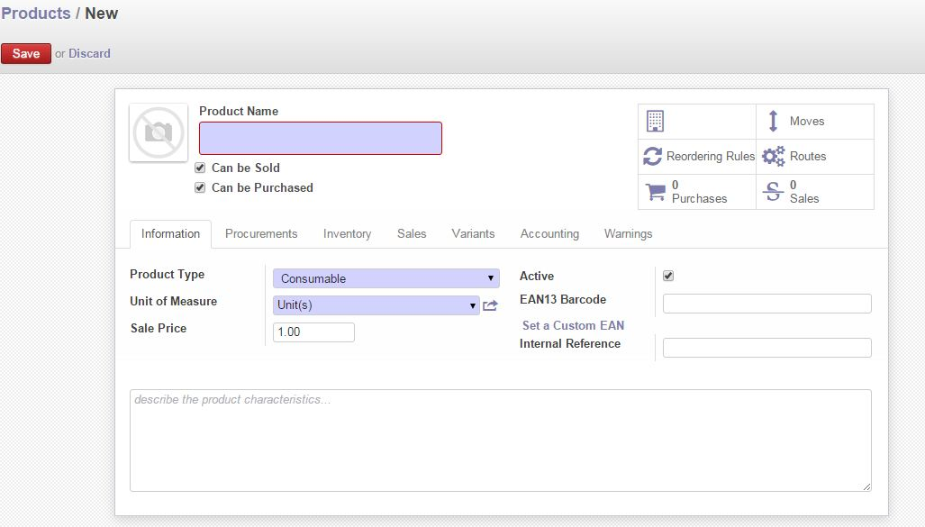

Fig: Product Basic Tab

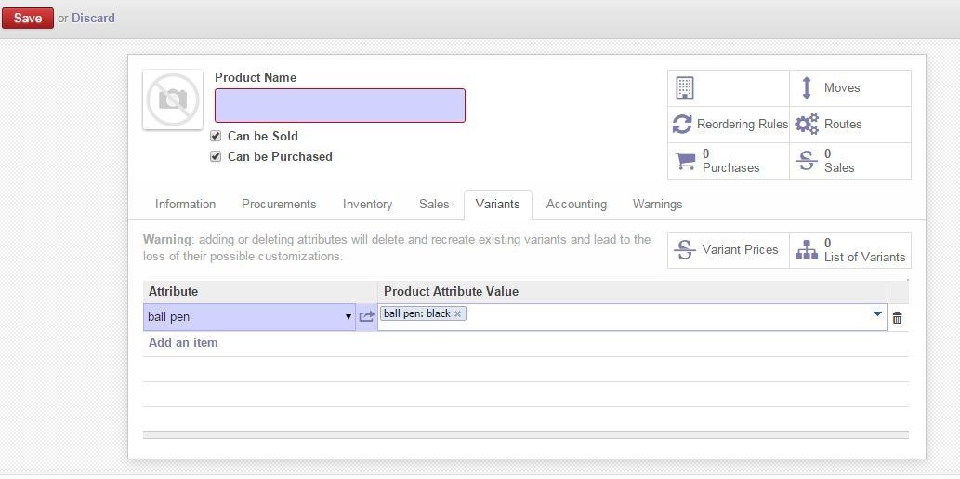

Fig: Product Variant Tab

## Indent

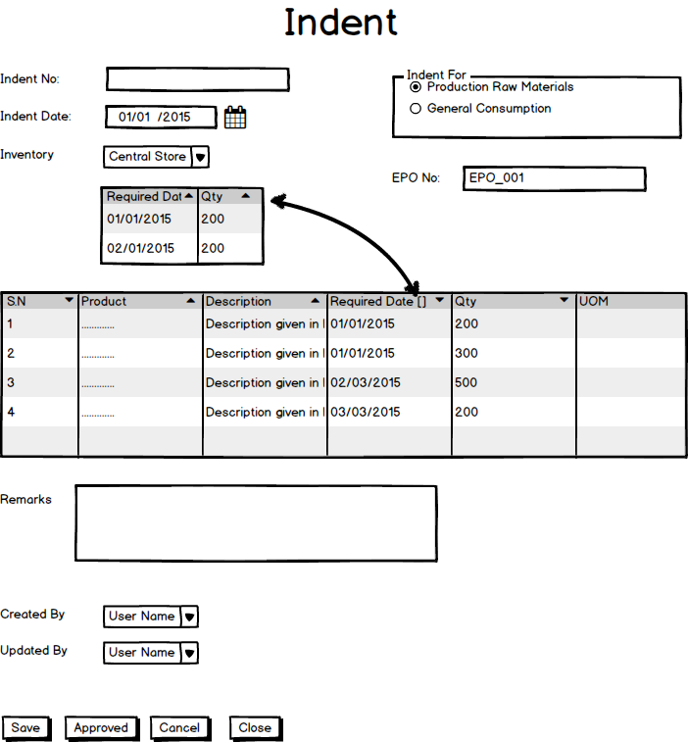

Fig: Indent

## Inventory Receive

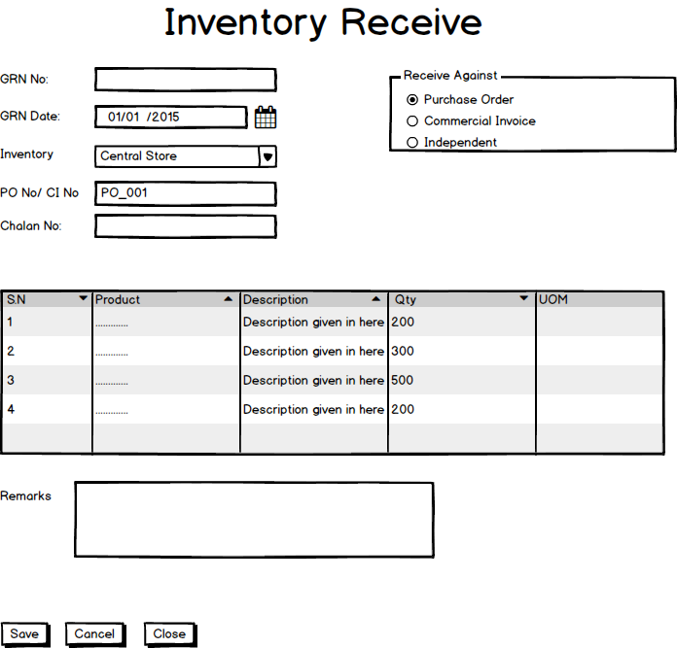

Fig: Inventory Receive

## Receive Return

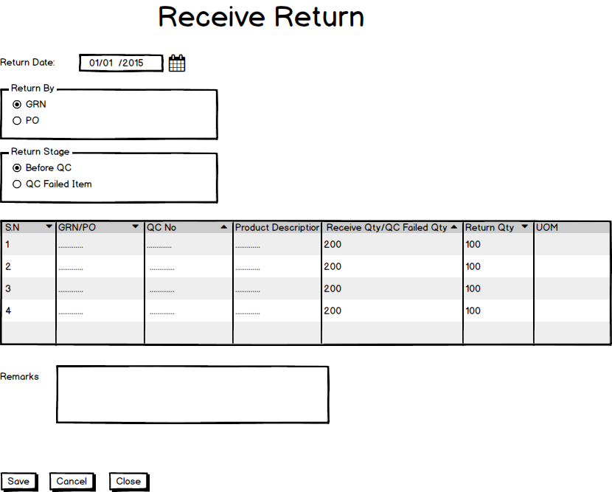

Fig: Receive Return

## Inventory QC

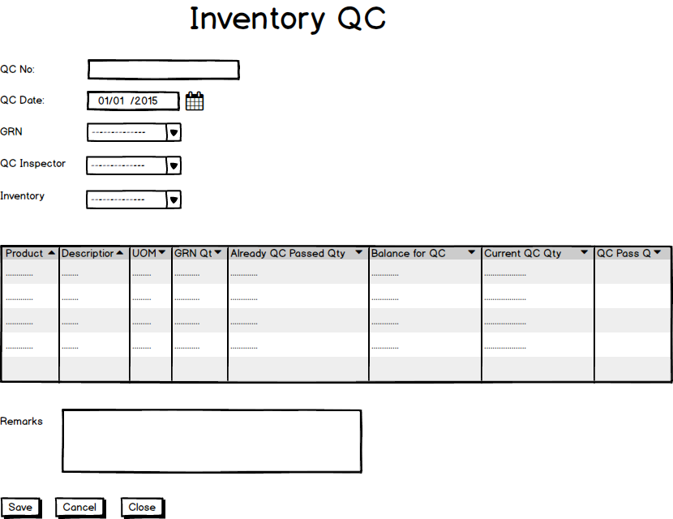

Fig: Inventory QC

## Inventory Transfer

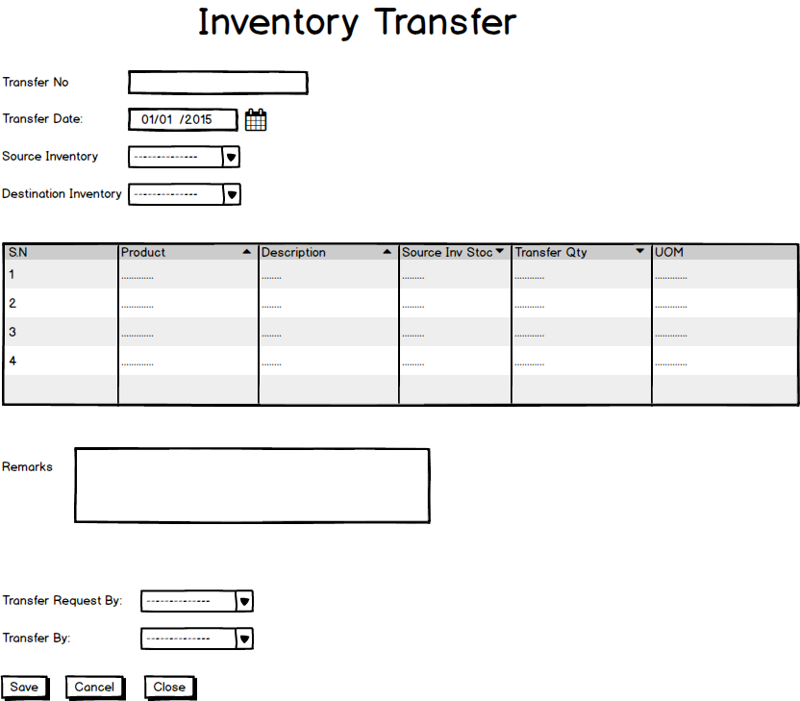

Fig: Inventory Transfer

## Inventory Item allocation &De-allocation

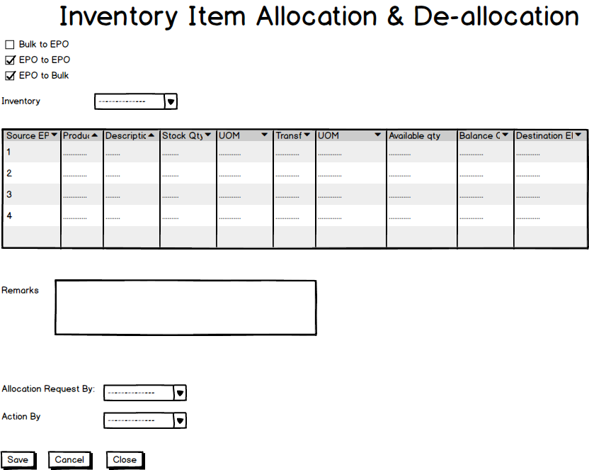

Fig: Inventory Item Allocation & De-Allocation

## Inventory Issue

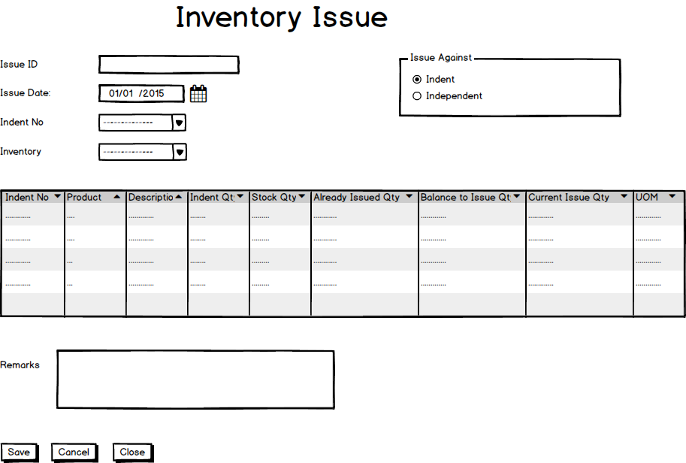

Fig: Inventory Issue

## Receive Inventory Issued Item

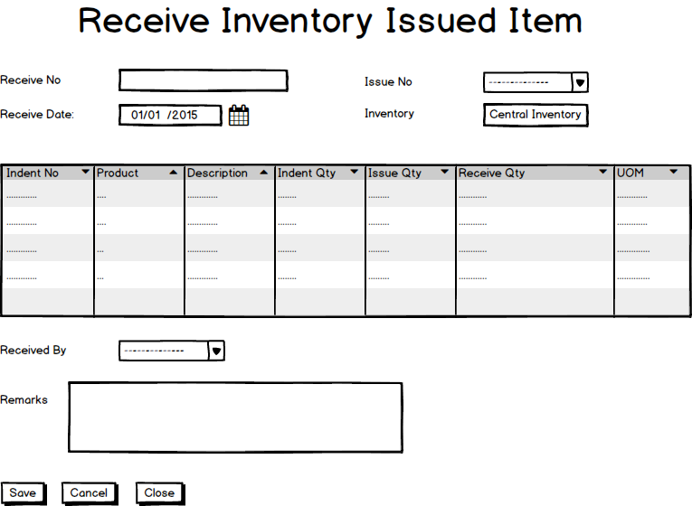

Receive Inventory Issued Item

## Issue Return

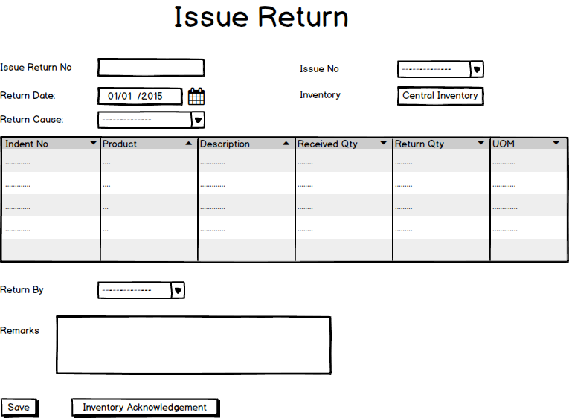

Issue Return

## Physical Inventory

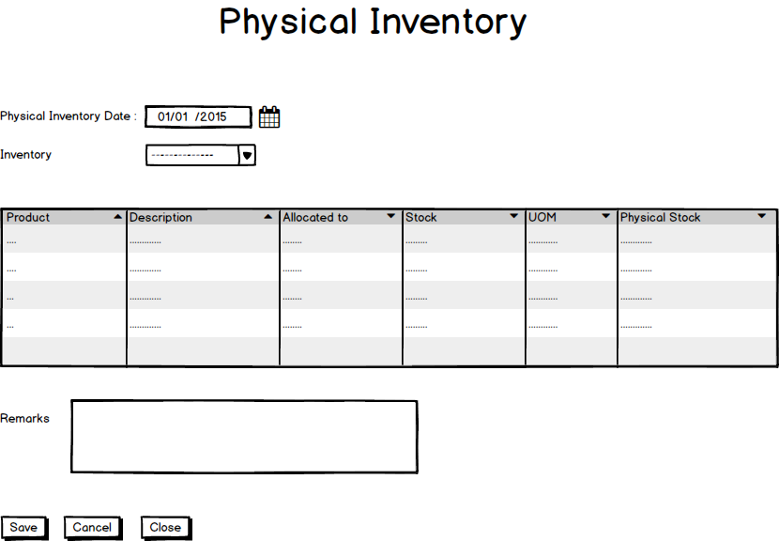

Fig: Physical Inventory

## Item Adjustment

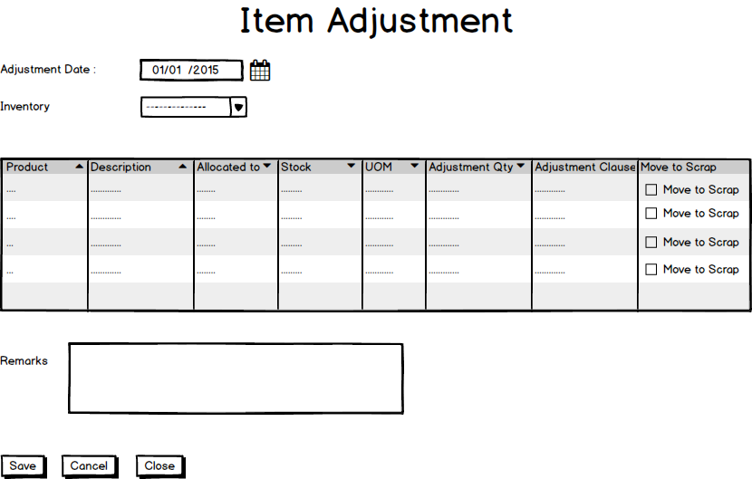

Fig: Item Adjustment

## Gate Pass out Process

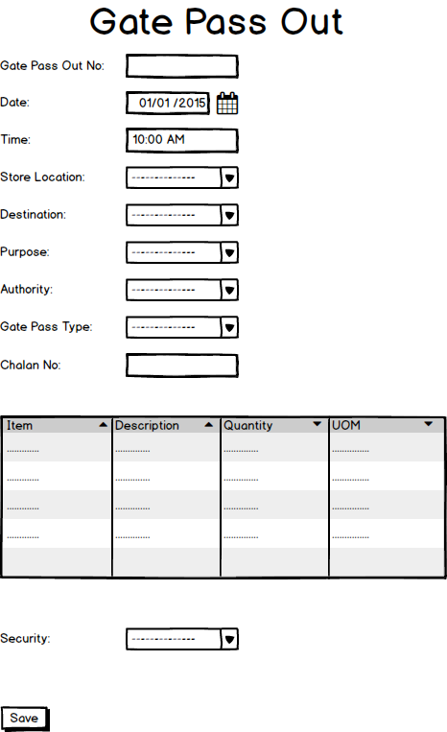

Fig: Gate Pass Out

## Gate Pass In Process

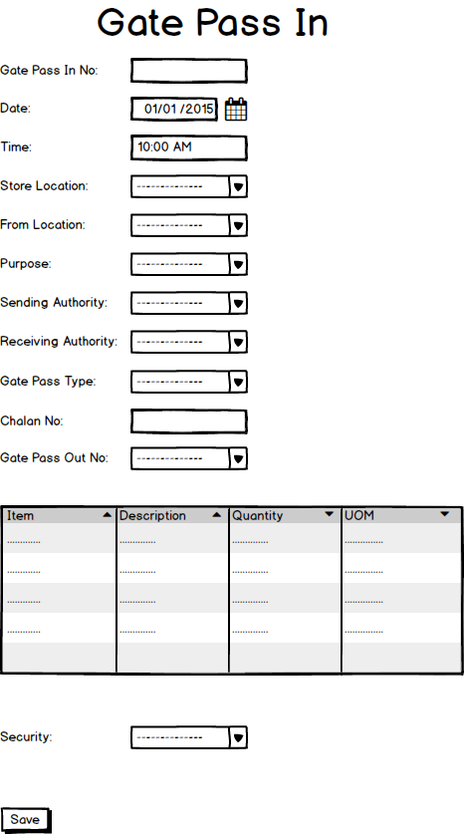

Fig: Gate Pass In